
CUSTOMER SERVICE EXCELLENCE &
CUSTOMER SERVICE FOR THOSE WITH SPECIFIC NEEDS
TTAI: New Zealand Certificate in Tourism Level 3
– with strands in Aviation, Tourism & Travel, and
Visitor Experience

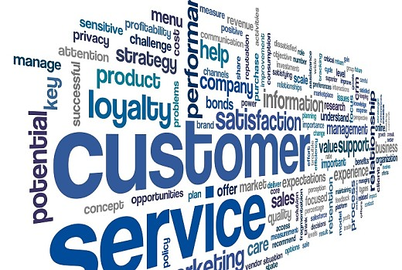
STUDENT WORKBOOK

© Copyright 2017 New Zealand School of Tourism Ltd.
These notes have been prepared especially for the students of New Zealand School of Tourism. All rights reserved. This publication constitutes intellectual property of New Zealand School of Tourism. This workbook is copyright. No part may be reproduced, stored in a retrieval system, or transmitted, in any form or by any other means, electronic, mechanical, photocopying, recording or otherwise without permission. Inquiries should be made to Head Office.

COURSE 2: CUSTOMER SERVICE
MODULE: CUSTOMER SERVICE EXCELLENCE & CUSTOMER SERVICE FOR THOSE WITH SPECIFIC NEEDS
CREDITS: 5
LEVEL: 3
Graduate profile 1 | Learning Outcomes | AssESSMENT
Implement customer service and information advice, applying appropriate communication, literacy, numeracy, and problem-solving skills, to enhance the visitor experience. | Be able to provide customer service in a tourism workplace and apply cultural understanding when dealing with customers. | TTAI: Customer Service Excellence:  Customer Service Role Play  (Cr3)
 | Be able to identify and describe specific needs of tourism and/or travel customers; and identify situations where a tourism and/or travel customer who has a specific need may require support and describe support mechanisms that may assist. | TTAI: Customer Service for those with Specific Needs:  Demonstration on providing Customer Service for those with specific needs.  (Cr2)

self directed learning STUDENT guide
TTAI: CUSTOMER SERVICE EXCELLENCE & CUSTOMER SERVICE FOR THOSE WITH SPECIFIC NEEDS
In order for you to gain the most value from your qualification and to prepare yourself for your assessment and the industry, make sure you complete all of the tasks below.
Monday to Thursday
Read “25 Culture Shocks from Around the World” on the Fly to Dubai website https://www.flytodubai.co.uk/blog/culture-shocks/ Design your own, similar flyer designed for overseas visitors arriving in New Zealand. Highlight 6 cultural differences you think inbound international tourists might find unusual or strange –explain these and be creative and visual - make your flyer stand out! Bring your Cultural Flyer to ART Day to share with your trainer and the class.

Read 1 hour of your compulsory book FISH.

Complete 5 x 30-minute sessions on Pathways Awarua Numeracy and/or Literacy

What is the total of your points? ________

Watch the following two clips and note your thoughts regarding the customer service given. Think about and note both positive and negative aspects of the service given for each video.
Meet The Parents – Airport check-in
https://www.youtube.com/watch?v=kwlQY8I3Uoo
____________________________________________________
____________________________________________________
____________________________________________________
____________________________________________________
Love Actually – Would You Like It Gift Wrapped?
https://vimeo.com/231958885 password: nzst
____________________________________________________
____________________________________________________
____________________________________________________
____________________________________________________

Complete the TTAI Customer Service Recap quiz on Moodle each evening. Aim to get 100%, you can keep trying.
My Mark is: _______

Any additional assigned tasks/work your trainer has set you

ART Day
9.00 – 10.00 Recap all the self-directed learning the students have completed
10.00 – 10.15 Morning Tea
10.15 – 13.00 Assessment followed by readiness checks/resits

TTAI Weekend SDL:
Cultural Tourism Project

Germany
Over the following modules you will complete an investigation of the key international visitor groups travelling to New Zealand. This will enable you to better understand their cultures and needs as visitors and how you, as a Tourism employee can be part of making their visit exceptional.
You are working at an I-Site and have been asked to put together a “handout” on up to six cultures that you can share with your team. It should be a minimum of one page and would include some of the following:
- Where do they come from? Unique things about their country & culture
- What experiences would they possibly want to have in New Zealand
- What would they want their customer service experience to be like?
- What behaviours would be acceptable and appropriate when working with them
- What is their language and what greetings could you use with them?
- What are their food/dining preferences?
Try to cover as many areas as possible and add anything else you find interesting along the way.
You have access to a cultural workbook in Moodle that will help you complete many of the above points. It is located in your TTAI Self-Directed Learning Guide in Moodle in the Recap & Extension section.

After you complete the handout on each culture over the four modules below you will work towards running a cultural celebration on ART Day to share all the things you have learnt. This handout can be kept as a helpful tool to refer to when you gain Industry employment.
Accommodation & Transport China
NZ Tourism Japan
CV’s UK
Customer Service Germany
Go Rentals & Regional O & A Cultural Morning
The cultural morning on Art Day will be a celebration and sharing of knowledge about all the cultures you have covered. You will be allocated a Country and in small groups, run a mini expo sharing music, language, food and your top tips for interacting with each culture.
Note: The modules may be completed in any order except for the last module.

table of contents
INTRODUCTION 1
What is customer service? 2
Customer service in the tourism industry 9
Characteristics of service 13
15 customer service skills every employee should have 14
Wendy Story 18
THE IMPORTANCE OF CUSTOMER SERVICE TO AN ORGANISATION 22
profit 22
customer satisfaction 22
reputation 22
customer loyalty 23
customer feedback 23
Components of customer service 26
Welcoming Greeting 26
positive attitude 30
Communication skills in customer service 34
Barriers to delivering excellent customer service 36
Evaluations, Feedback and Mystery Shoppers 39
Dealing with customers From other cultures 43
Tips for communicating with speakers of other languages 55
Handling multiple demands and tasks 56
What to do when you can’t answer a customer enquiry 59
HANDLING CUSTOMER COMPLAINTS 61
going the extra mile 65
Providing customer service in tourism 68
customer service assessment 92
customer with specific needs 96
TOURISM ENVIRONMENT 99
Transportation- MALPENSA EXPRESS 100
Accommodation 102
Attractions 103
HOW DO I INTERACT WITH PEOPLE WHO HAVE DISABILITIES? 104
BASIC POINTS OF ETIQUETTE 105
POSITIVE AND NEGATIVE LANGUAGE 105
Adapting your business to suit specific needs 108
ACCESSIBLE TRAVEL FOR ALL 111
VISUAL IMPAIRMENT 115
HEARING IMPAIRED 117
ELDERLY PASSENGERS 123
FEAR OF FLYING 123
other passengers with specific needs 125
Dietary Requirements 126
Company regulations 129
workplace assessment 141

INTRODUCTION
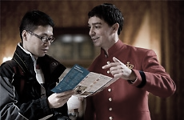
Customer service is the act of taking care of the customer's needs by providing and delivering professional, helpful, high-quality service and assistance before, during, and after the customer's requirements are all met. Customer service is meeting the needs and desires of any customer.

The travel and tourism industry is very dependent on customer service to enhance visitor experiences. Every contact a customer has with the tourism industry will leave an impression on the industry here, and even on New Zealand as a whole. One bad experience will often impact negatively on some of the good experiences tourists have. In the New Zealand tourism industry, all sectors need to work together to create a great tourist experience, and central to that is the delivery of excellent customer service.

Listed below are three jobs in the tourism industry. Describe the importance of customer service in each of them, and how the tasks and duties of each job directly relate to customer service.
- I-Site consultant

- Waitress in a hotel restaurant

- Tour Guide (attraction e.g. Hobbiton)

What is customer service?
Customer service is the service provided to customers before, during and after purchasing and using goods and services. Good customer service provides an experience that meets customer expectations. It produces satisfied customers. Bad customer service can generate complaints. Even worse than this is that some customers won’t complain to the business where they experienced inferior service, but instead express their dissatisfaction by never returning and telling all of their friends and associates about their experience. The business will never know about these customers being unhappy, and therefore won’t be able to address the problems with the service experience they are delivering.
Most people say that a positive customer service experience not only makes them happy, but creates a positive image of the company, and will more than likely lead them to purchase products or services from that company in the future. Positive customer service experiences are responsible for increased customer loyalty, repeat business, improved business reputation, increased profits and long-term business success.
However negative customer service experiences have an even greater impact on customers. Negative customer service experiences may be responsible for poor customer loyalty, lack of repeat business, poor growth, decline in business reputation, loss of profits and ultimately business failure.

1) Think of a company that you have purchased something from recently that has given you excellent customer service
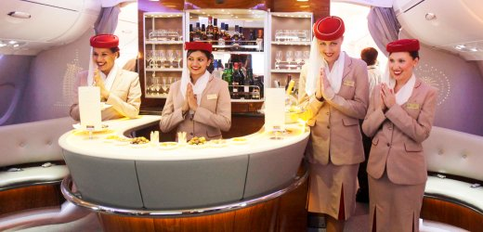
Company Name:
- Describe your positive service experience.

- Why did you believe that this was excellent customer service?

- Would you purchase products or services from this company again? Why or why not?

2) Think of a company that you have purchased something from recently that has given you poor customer service.
Company Name:

- Describe your negative service experience.

- Why did you believe that this was poor customer service?

- Would you purchase products or services from this company again? Why or why not?

Briefly describe the main points from the graphic on the next page about customer service satisfaction. Don’t just quote the facts and figures but also explain what they mean in relation to good and bad customer service. Use the headings below to assist you.
First impressions:

Permanent Effects:

Sharing experiences with others:

Social Media:

The Bottom Line:

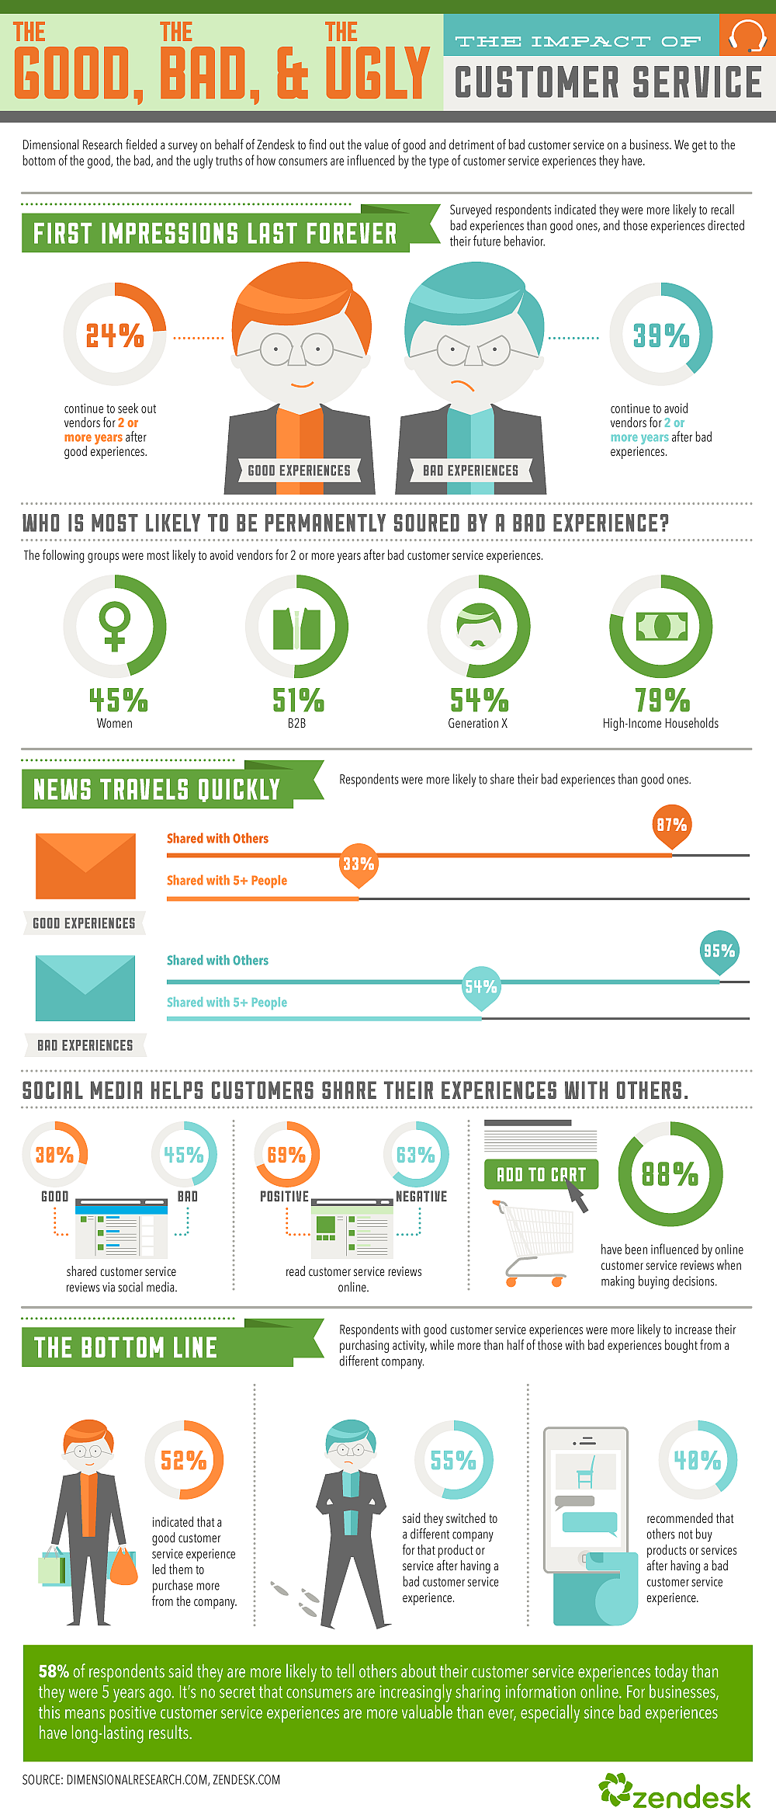

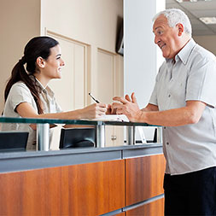
There are several essential skills that will help you to provide an excellent customer service experience for you customers. Once you understand why these things are so important and when you develop these skills by practicing, you’ll feel a lot more confident in yourself when assisting customers.
- Using the words in bold below, can you fill in the gaps to complete the essentials skills of customer service?

LANGUAGE SPEECH QUESTIONING
BODY LANGUAGE PRODUCT LISTENING
MEETING AND EXCEEDING

- Clarity of
- Positive
- Skills
- Knowledge
- Appropriate
- Skills
- Customer Expectations
- Now see if you can match these words up with the definition listed.

If we speak clearly our clients can understand us. Don’t mumble or talk too fast. Ensure the level of your voice is appropriate, not too soft but not too loud.
If we listen actively our clients feel valued and we pick up more valuable information from them. Listening to your clients helps you to determine their needs.
If we have good product knowledge and know where to find information we are better able to provide our clients with the best information and recommendations. We can also work more quickly and efficiently, plus our client’s will feel more confident about our professionalism.
If we use open and friendly body language our clients will feel more welcome and we will be more approachable. E.g. eye contact, genuine smile, leaning forward, nodding etc.
If we choose the right words and grammar to communicate with our client then they will understand us and we have less chance of offending them. Don’t use industry jargon or slang as clients don’t understand it and will be left feeling confused.
If we use lots of open questions we can gain more information from our client, we can gain it quickly and it will be more valuable information which you’ll use to establish your client’s needs. Open questions generally begin with “when, how, where, why…” etc., and anything else which forces the clients to answer using a sentence or two. Closed questions get a “yes or no” answer from the client.
If we are constantly trying to meet & exceed the expectations of our customers then they will be happy with the service they have received, be more likely to bring repeat business, tell their friends about us etc. We will also feel better about the job that we do.

Customer service in the tourism industry
The reasons and motivations for people travelling can vary greatly. People who travel to see friends and family are usually looking for fast, friendly and efficient service. People travelling on an overseas holiday are looking for more interpersonal interaction. The tourism industry is a people based industry and many of the products and services are experiential in nature- meaning that the experiences that travellers have directly reflect on their satisfaction and enjoyment.
Travellers who partake in group coach tours around New Zealand for example, often return home and speak as much about their tour guide and the people they met during their travels, as the amazing scenery and thrill seeking activities they did. So there is a huge focus in the tourism industry of delivering excellent customer service which meets and exceeds customer expectations. Education, training and recruitment of staff is also critical to the delivery of excellent customer service experiences for travellers.

Look at the following tourism job advertisements. Identify the areas in the actual advertisement and others from the job which you think involve customer service.
- Cave Rafting Guide;
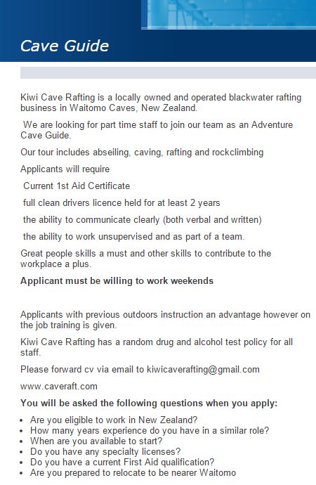
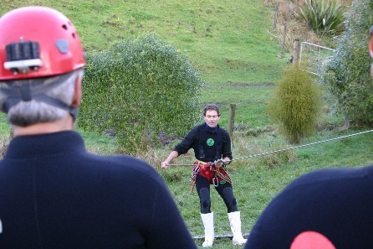
Areas of the job which involve customer service:

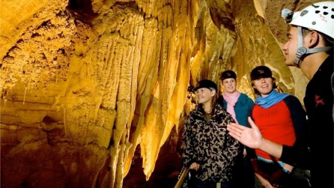
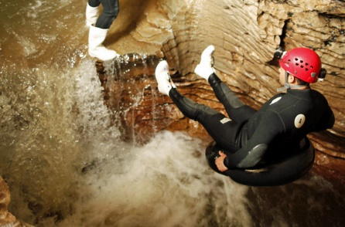
- Passenger Service Ticketing Agent
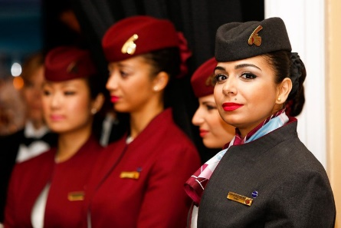
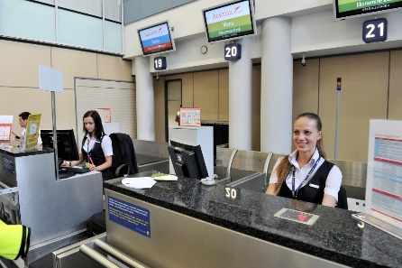
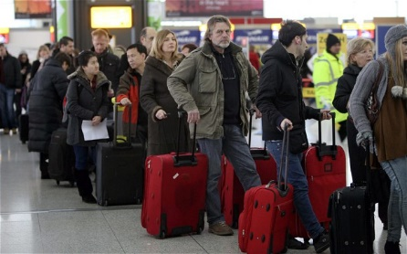
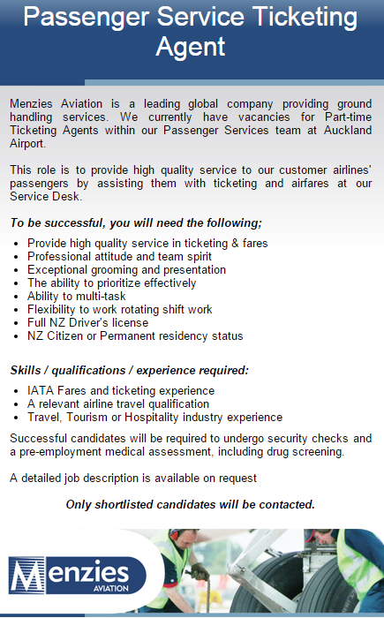
Areas of the job which involve customer service:

- Front of House Wait Staff
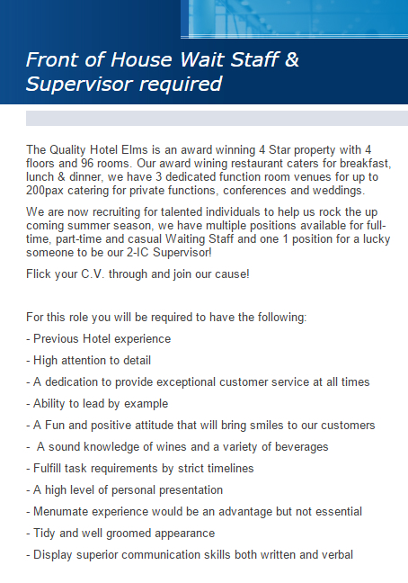
Areas of the job which involve customer service:
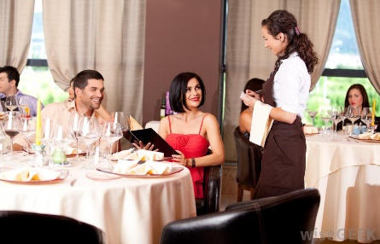

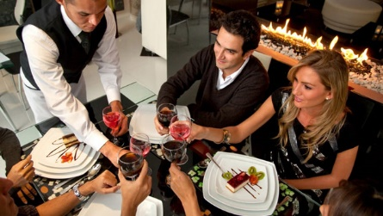

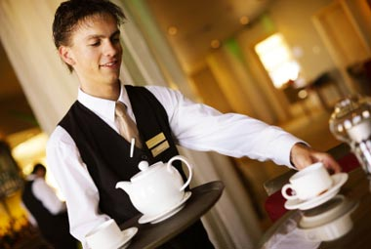

Characteristics of service
There are several important characteristics that a service has. These are:
- Intangibility: Service is experienced-you cannot see or touch a service.
- Perishability: Service cannot be stored for future use. It is generated and consumed at the point it is given.
- Inseparability: Service involves people. The service provider and consumer must be together for the delivery and experience of service to take place.
- Variability: Each service is unique and cannot be replicated as the point in time, location, circumstances, conditions, current configurations and/or assigned resources are different for the next delivery, even if the same service consumer requests the same service.

Identify which characteristic of service is shown in each example below.
- If travelling by train, coach or air the service will only last the duration of the journey.
- If travelling by plane the service quality may differ from the first time you travelled by that airline to the second, because the Flight Attendant is more or less experienced.
- You receive excellent customer service and feel good for the rest of the day.
- You need a haircut, so you go to the hairdresser, and she cuts your hair how you like it.


15 customer service skills every employee should have
Providing good service
Listed below are 15 qualities that will make you perfect for a job in customer service. Do you have these qualities? Check the appropriate boxes below to indicate if you believe you have these skills or of you need to work on any of these skills. Give a reason for your answer.

Superior communication skills. If you aren’t a good communicator, then customer service may not be the field for you. Customer service jobs require that you deal heavily with the public. Do you know how to handle the many problems that come with customers? Communication skills are essential to get a good customer service job.
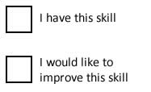
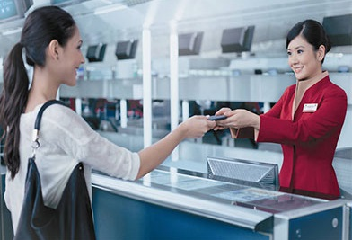
Self-control. You are sure to come across customers who will be difficult to deal with. For this reason, you must have self-control. You must be able to handle both the easy and hard times that comes with serving the public.
A good work ethic. As with any job, you need to have a good work ethic. You must be willing to put the needed work in to provide exceptional customer service.

Patience. It is important to have patience for those customers that no one really wants to deal with. The more patient you are, the better off you will be when working in customer service.
The ability to be relatable. Customers want to feel like they can relate to the people they are working with. Whether it is face to face or over the phone, the ability to be relatable is without a doubt an important quality.
Caring. Customers are also looking for someone who actually cares about them, not just making a paycheck. To land a good customer service job, have a caring attitude in general about helping people.
Compassionate. Similarly, compassion will carry you far in a customer service job. Are you compassionate?
Willing to help when needed. If you aren’t willing to help others solve problems, customer service is likely not the field for you. Be willing to help in whatever way needed in an effort to get a good customer service job.

Experience in dealing with the public. Higher paying customer service jobs will require that you have previous experience in dealing with the public. If you don’t have this experience, be willing to start at the bottom and work your way up.
Knowledge of the product. If you work for a company that sells something, it is important to know the product inside and out. This will allow you to be of the most help to your customers.
Phone skills. A good paying customer service job will require that you know how to work multi-phone lines and have an appropriate phone manner. How are your phone skills?
Work well with others. If you can’t be a team player, you are not going to find the best customer service job. Good customer service takes teamwork. Working well with others is an essential skill for being successful.
Okay with being managed. Are you okay with not being your own boss? Customer service jobs are usually managed. This means that you will have a boss to answer to. Can you handle taking direction from a superior authority? If not, customer service may not be for you.

Willing to go the extra mile to please customers. The customer always comes first and is ALWAYS right. You must be willing to go the extra mile to please each and every customer. Sometime, this can be at the expense of your pride. You must be willing to swallow your pride and move on.
Customer appreciation. A good job in customer service will require that you have a general appreciation to customers. After all, they are the ones who will be providing you with a job. Without them, your job would not be necessary.

Source: http://www.business2community.com

Wendy Story
Wendy Story
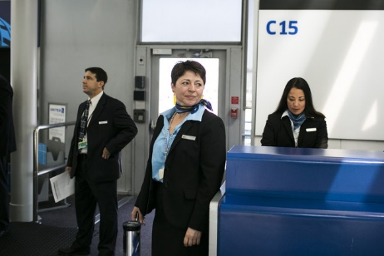
Now watch a short video about giving excellent customer service in the tourism industry and answer the questions which follow;
- What was Wendy’s job, and what role did customer service play in it?

- What was the biggest problem Mr Gee (the speaker/passenger)
had?

- How did Wendy solve the problem?

- What were the benefits of Wendy’s actions?

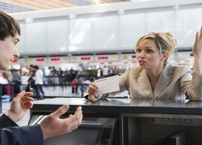
You’ve just watched a video about excellent customer service, now read the following article about the effects of poor customer service.
HOW DOES POOR CUSTOMER SERVICE AFFECT A BUSINESS?
by Lisa McQuerrey, Demand Media
Poor customer service can negatively impact a business in a variety of ways. This is especially true for small businesses that rely on repeat business and positive word-of-mouth advertising for its success. In addition to running the risk of alienating current customers with sub-standard service levels, chronically poor service can impact the business’ potential for attracting new customers as well.

Loss of Current Customers
Poor levels of customer service can cause you to lose even the most forgiving of customers. Consumers tend to do business with a company because it’s convenient, it’s a habit, or they’re looking for particular product or service that’s hard to find elsewhere. Even these stalwart customers can be turned away by inferior levels of service.

Loss of Potential Customers
Poor customer service has the potential to cost your business customers before they even buy a thing. When new patrons walk into a business and find themselves ignored, talked down to or subjected to long lines and uneducated employees, they might head for the door before they even reach for their wallets. Anything that makes it challenging or unpleasant for a person to do business with you should be cause for alarm, warning you that your service levels need improvement.

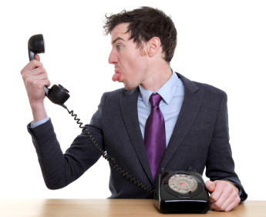
Loss of Future Customers
Customers who experience poor service levels often tell their friends and family members about the bad experience to warn them away. This will cost your business potential customers. People will have already formed a negative opinion of your business before ever setting foot in your door.

Loss of Reputation
A reputation for poor service can be hard to shake. It can keep other businesses from partnering or working with you. It also can turn away good employment candidates who might assume that if customers are treated poorly, employees are treated badly as well.

Loss of Employees
Even poor-performing employees don’t like to be yelled at or scorned by unpleased customers, which can result in high turnover among your workforce.

It is costly and time consuming to constantly have to advertise for new workers, then screen and train them. Customers might start to wonder why your business can’t retain staff members and question the management practices of your business.

Loss of Profits
Poor customer service typically results in fewer customers, which translates into lower sales and profits for your business. This can initiate a vicious cycle in which a company tries to save money on staffing or customer service training, which makes service levels spiral downward even further. A company that can't keep pace with the financial demands of running a business faces increasing operating debt and ultimately, a loss of the business.

Source: http://yourbusiness.azcentral.com

- List as many benefits of giving excellent customer service and the impacts of giving poor service as you can in the table below:
Benefits of excellent customer service | Impacts of poor customer service
The importance of good customer service

THE IMPORTANCE OF CUSTOMER SERVICE TO AN ORGANISATION
Customer service is important to an organisation in the following areas:
- Profit
- Customer satisfaction
- Reputation
- Customer loyalty
- Customer feedback

profit
Levels of customer service ultimately affect a company’s profit. Highly satisfied customers are more likely to purchase products and services, and highly motivated and trained staff are also more likely to be able to sell more products and services. In simple business terms there is a direct relationship with profit. The better the service, the more likely the chance of a sale, the higher the profit.


customer satisfaction
Customers who are satisfied with the service they get are more likely to purchase products and services, return in the future as repeat customers, and tell their friends and family about their service experience. High levels of customer satisfaction are a good indicator of a successful business.

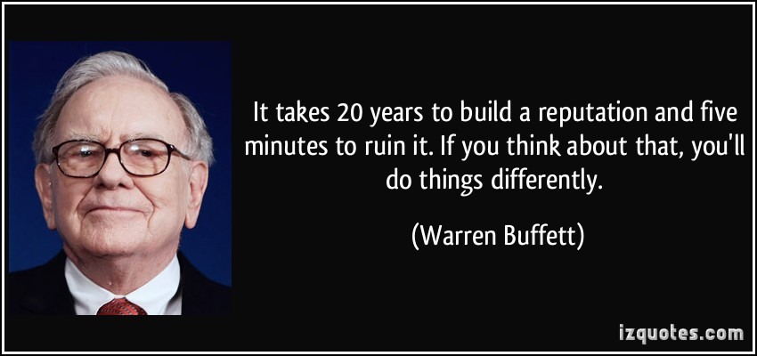
reputation
Reputation is what people are saying about a business. Having a reputation as an excellent provider of customer service is hugely beneficial to a business and is a driver for repeat business. It can lead to increased profits and ensure the success of the business in the future.

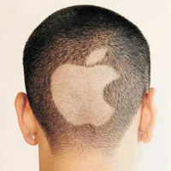
customer loyalty
Loyalty can be defined as a customer continuing to believe that an organisation’s product or service offer is their best option. Customers are often fiercely loyal to brands such as Apple or Levis, and will always buy these products above all others. Loyalty may also come in the form of repeat business, with customers continuing to return to a business multiple times to purchase products and or services.

customer feedback
Monitoring Customer Service
Customer feedback can be defined as being information coming directly from customers about the satisfaction or dissatisfaction they feel with a product or a service. It is an important measure of a company’s current success. Feedback is usually obtained through surveys, interviews, complaints, comments boxes, online reviews and ratings.
Glasgow Airport

You are going to read an article about the importance of getting customer feedback.
- Before reading define the following terms:
Focus group

Cross section:
Ratio:

Customer charter:

Now read the article and answer the questions which follow:
Article: Glasgow International Airport launches customer service charter
Glasgow International Airport has launched its customer charter, the first of its kind in the UK, and has trained staff to put themselves in the place of those using the airport, in a bid to become a destination of choice for travel from Scotland.
The organisation is working with Rainbow HR (Human Resources) who were brought in to support the international airport’s desire to become the best airport in Europe in terms of customer service.
In 2010, Glasgow Airport undertook a customer survey asking passengers what was important to them when travelling through the airport with results providing the management team with the fundamentals to develop a customer charter.
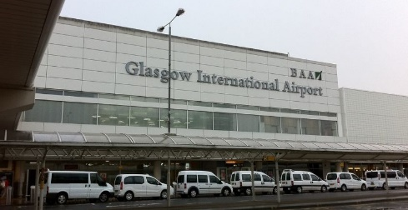
Working with Glasgow Airport’s management team, Rainbow HR held a series of staff focus groups from a cross section of employees to understand what great service looked like to them and this formed part of the training program.
Following the customer survey and the development of the charter, the airport implemented customer service training. The objective was to ensure staff displayed behaviour in line with the charter’s key commitments which were to be efficient, friendly, helpful and knowledgeable in a clean litter free environment.
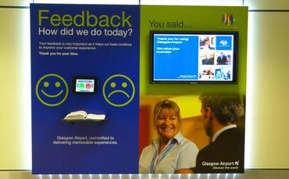
To enhance the training experience Glasgow Airport and Rainbow HR went onto to design a DVD, which focused on staff attitudes. The film, which is based on real life customer experiences, showed a good and bad scenario. The DVD followed two passengers from the moment they were dropped off until they boarded the aircraft. While the scripts were identical, the attitudes employed by staff were incredibly different.
The DVD encouraged staff to put themselves in the customer’s shoes and understand the impact of poor service on the customers experience within the airport and that this is all down to individual staff attitude in delivering that good or bad service.
The impact of the training showed a positive shift in the ratio of compliments to complaints with customers reporting 7:1 in favour of their visit.
Amanda McMillan, managing director of Glasgow Airport, said: “Our customer charter clearly outlines our commitment to our customers and in making such a public commitment, we fully recognise we will be held to account at all times. We believe this approach will enable us to build upon current standards and ultimately lift Glasgow Airport to a new level in the eyes of our customers.”

As part of the customer charter’s commitment to improve service at the airport, an interactive feedback station has been installed in the security hall, which captures instant feedback from every person travelling through security. The station is the first of its kind for any UK airport.
Following on from the success of the initial customer training programs, the airport is rolling out its training plan by working with the remaining 4,000 third party employees based at Glasgow International Airport to ensure that every customer at the airport has a great experience no matter who they come into contact with during their visit.
Source: http://www.hrmagazine.co.uk
- Why did Glasgow airport develop a customer charter- what was their purpose?
- How was the training enhanced?

- How was training enhanced In terms of staff training what aspect was focused on in particular?
- What evidence was there of the success of the programme?

- What is the next step in the training process?

Components of customer service
There are certain fundamental components that are essential to producing excellent customer service. These are:
- Greeting and farewelling customers
- Attitude
- Communication skills

Let’s look at these in more detail.

Welcoming Greeting
When you greet a client, you make a first impression. It may be the only impression you get to make if it’s not done well. The client will assess you and the business within seconds. This is why the greeting is so important. Greeting clients is also a part of creating a warm friendly atmosphere. When you come into a shop, travel agency, airline office, tourist attraction etc., it is nice to be acknowledged and to be greeted.
Read the following article about how to greet customers and take notes on what you find are the most important points.
ARTICLE
When someone greets you and says, “Hello”, you will probably respond with your own greeting. Even in your worst mood, when someone greets you with a genuine smile and sincerity, most probably you will acknowledge the greeting and respond appropriately. Such greeting can be so powerful that it can even turn your frown in to a smile and change your mood entirely.
Greeting is one of the basic functions of communication and triggers positive conversations. It helps us connect to people at a more personal level. Especially for strangers, greeting someone before initiating a conversation is a must if you don’t want to get a nasty stare or a negative response. A warm, genuine, and sincere greeting can cause even a stranger to open up, break down defensive walls, and be comfortable.
When you are introduced to a new acquaintance, your greeting will form part of that person’s first impression of you. How that person greets you will influence your first impression of that person.

If you are tasked to conduct a talk, your first 60 seconds will determine how you can influence your audience’s attention and interest. Within this first 60 seconds, your introduction includes your greeting and how you do this will set the mood and mind set of your audience throughout the entire duration.
It’s amazing how a simple and effortless gesture can have a huge impact and pay off immediately. It is also amazing how difficult it seems for businesses to consistently and appropriately implement this as part of their customer service practices. Whatever the reasons are, the fact remains that greeting customers is a MUST.
It is a common expectation and practice of courtesy that when a family member or a friend knocks on your door, you try to drop whatever you are doing as quickly as possible to get the door as soon as possible and warmly greet him/her. Is this a biased action because that person is special? Fair enough, but aren’t your customers also special?
Every customer wants to feel special and this is because they are special. Thus, should be treated special. No customer would want to feel ignored and should never be ignored. When a customer enters your store, they will expect to be acknowledged. They will expect to be greeted. They will expect to be assisted. They will expect the best experience in every visit to your store.
Customers don’t want to feel that they are just customers and their only purpose when they visit your store is to purchase your product. They don’t want to feel that they are just a part of your statistics. Ineffective greetings make them feel this way.
There are certain particulars that customers want when they are greeted. Aside from being friendly, below are the common characteristics.
First 10 seconds – Studies have shown that the first 10 seconds once customers enter the store can be a deciding factor if they will continue shopping at your store or step out in the next 10 seconds. Customers want to be acknowledged and greeted within the first 10 seconds. When customers are ignored, there’s a high probability that they will take their business to a competitor where they will be attended to immediately.
Eye Contact – Employees who greet customers while doing something else might as well not do it. This is a very disrespectful behaviour. Unless you’re assisting another customer, drop what you are doing, look the customer in the eye, and greet the customer.
Smile –A greeting without a smile only sends a message to your customers that it’s just a requirement, whereas a greeting with a smile is more genuine.

However, you have to be careful because, believe it or not, customers can see through fake greetings and smiles. It’s a no brainer that greetings and smiles are fuelled by our emotions. The same emotions are felt by the recipient.
Use their name – Customers love to hear their names mentioned in business dealings. This doesn’t just make them feel special, but it also gives them a sense of “belonging”. Make an effort to note down customer names and their usual purchases.
By doing so, your customers will feel that you care enough and value them to know something about them. Greeting customers by name develops a more personal store-customer relationship. If you do not know the name of the customer yet or forgot it, you can get away from it for now, but make the customer feel that you recognize him/her by saying something like, “Hi, it’s nice to see you again.” or “Hi, welcome back.”
Personalise – Don’t use the same canned greeting for each customer. Be observant. Use any visual, verbal, or olfactory cues from the customer to personalize your greeting. A customer who steps in your store who looks tired, panting, and sweaty will not appreciate a simple, “Good day, how can I help you?” It’s quite obvious that this customer is not having a good day and is feeling uncomfortable. A better greeting would be, “It’s indeed hot outside. Would you want to take a seat for a moment and a glass of water?” This skill is may be difficult to attain, but with enough experience and proper training, it can become 2nd nature.
Introduce yourself – Though not a necessity especially if employees wear name tags, it never hurts for employees to introduce themselves especially for new customers. This further makes the conversation more personal.
Give space – Never go past the personal space of the customer. This will make them uncomfortable. Stop when you’re at least three feet away from the customer.
Be genuine and sincere – Being genuine and sincere when you greet customers can either positively enhance the customer’s experience or turn them off. Being genuine and sincere is what makes a greeting warm and heartfelt. Just like fake smiles and greetings, customers can also feel if you are genuine and sincere with your greeting.
This is a decision. This is either a Yes or No. It is either you’re genuine and sincere or not. There’s no in between.
When customers perceive that your store has a friendly environment that makes them feel special, important, valued, and gives them a sense of belonging, expect to see them keep coming back to your store.

Source: http://www.retailwiseusa.com/the-importance-of-greeting-customers/
- When you greet or address a friend or family member what do you say?

- Do you think these are appropriate for the workplace?

- If you went to the doctors and the nurse said to you ‘What’s up man’…. would you have instant trust in them to do their job?

- As the article says it is good practice to refer to people by their name or title if you know it. It sends a message that you are interested in them and their business. So how would you greet your regular client John Jones, who has just walked into your place of business?

- How could you use Maori greetings and farewells in customer service in New Zealand? Explain and list the appropriate Maori greetings and farewells you could use.

positive attitude
“Your attitude, not your aptitude, determines your altitude”-
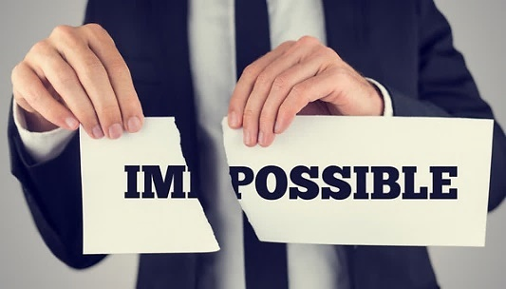
Zig Ziglar, motivational speaker
Attitude is a way of thinking that defines your behaviour. Your attitude is reflected in your appearance – dress and grooming, speech, body language, and your voice. All of these can have a positive or negative effect on your customers and clients.
Always having a positive attitude can be difficult, but in the tourism industry where a great deal of products and services are experiential, it is crucial to maintain a positive attitude.

Why is a positive attitude important in the tourism industry?

It is important to do your part to make sure that every contact is a good customer experience delivered with a positive attitude. You need to remember:
- Tourism is perceived to be a fun industry
- Your attitude represents your company and your own self respect
- You need to wear a professional mask, leaving any personal issues at the door when you enter the workplace. This may be difficult at times, but your actions with regards to customer service in tourism will have a direct impact on the visitors’ overall experience.

Johnny the bagger
Watch the movie clip about Johnny the bagger and discuss how Johnny gave excellent customer service through his attitude and initiative.


Practice interacting with a client by greeting them professionally and telling them about any tourism product, and all the while maintaining a positive attitude.
In pairs, one student takes on the role of a sales assistant/receptionist at an activity in the tourism industry in New Zealand that you have learnt about previously. The other student will take on the role of the customer trying to make a booking or just wanting to know about the activity/attraction.
For example one of you may be the sales assistant at Taupo Bungy and the other a customer looking to find out about bungy jumping and how much a jump is etc.
Refer to the next page which includes part of the assessment criteria which you can refer to during this roleplay exercise. Make sure you competently demonstrate each aspect.
You need to focus on;
- Greeting the customer professionally and within an appropriate timeframe (should be under 5 seconds).

- Appropriate verbal and non-verbal communication is demonstrated. Eye contact, smiling, facing towards them,
use of voice pitch/modulation, used appropriate language, i.e. no jargon

- Positive personal behaviour towards the customer. Confidence, enthusiasm, friendliness, interest in the customer, using their name, giving space, being genuine and sincere
- Farewelling the customer professionally.

ER | Evidence: (write notes) | C/NYC | C/NYC
1.1  Customer is greeted professionally and within an appropriate timeframe  (should be under 5 seconds). | Write down how the student greeted the customer.
1.2  Appropriate verbal and non-verbal communication is demonstrated. | Tick the aspects which the students displays.  □ Eye contact  □ Smiling  □ Facing towards them  □ Use of voice pitch/modulation  □ Used appropriate language, i.e. no jargon
1.3  Student demonstrates positive personal behaviour towards the customer. | Tick the aspects which the students displays.  □ Confidence  □ Enthusiasm  □ Friendliness  □ Interest in the customer

Communication skills in customer service

Communication plays an important role in customer service. Without it customer service would not be possible. We are now going to look at the most important aspects of communication in the customer service process.
HOW TO COMMUNICATE BETTER
As communication is essential to good customer service, knowing how to communicate effectively is vitally important. The following six points can assist you;
- Use open-ended questions (avoid closed questions – kills the conversation).
- Active listening (tells the other person that you’re really listening and more importantly shows that you’ve understood by summarising what the other person has said).
- Focus only on the other person, push out any distractions around you.
- Engage with the other person: body language is important, focus all of your attention on the other person.
- Don’t make assumptions: ask questions, find out what the other person is thinking/feeling.
- Avoid antagonistic (hostile) sentences: these are seen as a form of attack.
Active listening:
Active Listening is learning how to not only receive information but to understand it and to let the other person know that you understand it.
Active listening
Using open, closed and clarifying questioning:
Open questions require a longer answer and involve words such as why, who, when etc. whereas closed questions are yes or no, or only require a one or two word answer.
Clarifying questions are questions that you ask to get even more detail. They are simple questions of fact. A combination of open and closed and clarifying questions need to be used to effectively communicate with customers- closed questions require a one word or very short answer.
Open & Closed questions
Imagine that you are a travel agent. A customer approaches you and says “I’d like to go on holiday”. What are three open questions you could ask them to assist you in trying to meet their needs.

Communication barriers
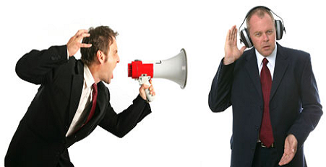
Barriers stop the message from being understood and translated into feedback. Barriers can be:
- Cultural differences
- Stereotyping
- Word choice
- Status
- Gender
- Physical separation
- Industry jargon

- Voice modulation
- Articulation
- Not actively listening
- Noise
- Interruptions
- Technical problems
- Personal issues of customer (e.g. anger, frustration etc.)
- Fear of impending circumstances
…these are all barrier and can impact on customer service greatly. For example, stereotyping can lead to guests feeling unhappy or treated in a demeaning way. Language may cause misunderstandings.

Complete the tables on the next few pages and identify the ways to overcome the barriers listed.

Barriers to delivering excellent customer service
Barrier | Ways to overcome the barrier
Cultural Differences  Misunderstanding messages because you don’t understand the language, customs, beliefs or values of another person due to their cultural background.  Example: Japanese people don’t like to say no as they think it is disrespectful toward you – therefore you may think they understand something you said when in fact they don’t.  Having difficulty getting a message across because you speak a different language or have very different accents. | Eg Cultural differences – Speak slowly if their first language isn’t English, be understanding of different values other people may have etc.  Choose simple words. Rather than “grab some lunch” try “go and get some lunch”.
Stereotypes
Misunderstanding messages because you assume you already know the other person’s wants/needs based on their appearance, age and so on.
Example: A backpacker walks in to book accommodation and you automatically go to the Backpacker Guide as you assume they can’t afford anything else when in fact they want to stay in a hotel.
Word Choice
Misunderstanding messages due to the type of words being used not being appropriate to the customer and/or situation.
Example: Using the latest street slang on an elderly client – they probably won’t understand you and may even get frustrated with you.
Non-Verbal Communication
Misunderstanding unspoken messages or being confused or distracted by unspoken messages
Example: Someone who constantly taps one foot may find that others don’t focus on them as the tapping is distracting. Does foot tapping mean they are not interested or that you need to get on with it? Same applies to outrageous clothes, hair etc.

Voice Modulation & Articulation
Speaking too slow so people are bored and don’t listen, or too fast so people can’t understand. Not pronouncing your words clearly and correctly so that people can’t understand.

Example: An airport CSO who speaks very fast and therefore people have a hard time hearing which gate they need to go to and what their boarding time is.
Physical
Mainly relates to illness or disability, which prevents messages from being understood.

Example: Someone on a flight who is hearing impaired may miss the safety briefing.
Personal
Mainly relates to your personality or emotional state preventing you from sending and receiving messages effectively.
Example: Had an argument with your partner on the phone at work and then couldn’t focus properly on the next customer.
Age Differences
Refers to making an assumption about a person based on their age, which prevents messages being sent. Can also relate to the age gap being so big that the communicators cannot find common ground.

Example: A tour driver not stopping at the AJ Hackett Bungy because all of his passengers are over 60 years, and he thinks they won’t want to do it.
Educational
This is often when two people are trying to discuss the same subject however one has lots of knowledge and one has very little. Can also mean when someone is intimidated by the academic ability of another, or frustrated by someone’s lack of academic ability.

Example: A travel agent who knows nothing about archaeology trying to arrange a special interest tour for archaeologists.

Organisational
When structures and hierarchy in an organisation make it difficult for communication to take place.

Example: A junior knows there is a problem but due to the way the more experienced staff treat her, she is too scared to say anything.
Not Listening Actively
This often relates to people being distracted when others are trying to tell them something and therefore misunderstanding or not getting the message at all.
Example: Reservationist is distracted and thinks a client said they wanted to go to Auckland when in fact they wanted to go to Christchurch.
Noise
There may be noise which is distracting to the sender or the receiver.

Example: The sender or receiver finds it hard to talk or listen because people are laughing and talking in the room, building site outside the front door etc.
Interruptions
Interruptions which are a stop start to your communication

Example: Such as people trying to talk to you when you are on the phone, customers butting in to ask questions, too many people talking to you at once etc.
Technical problems
Technical problems that make it hard to communicate.

Example: Such as Internet Service Providers going down, faxes jamming or running out of paper, phone lines going down, phone systems overloading etc.

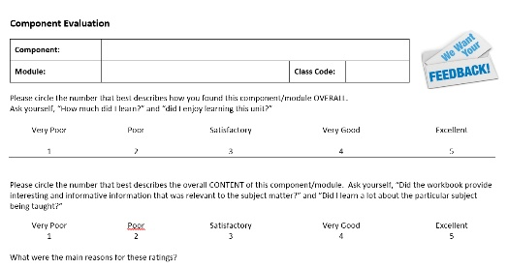
Evaluations, Feedback and Mystery Shoppers
As we just learnt feedback is essential to the customer oriented organisation. Even at the New Zealand School of Tourism we are constantly seeking feedback from our students with component evaluations.

List and briefly describe as many ways of getting customer feedback as you can;
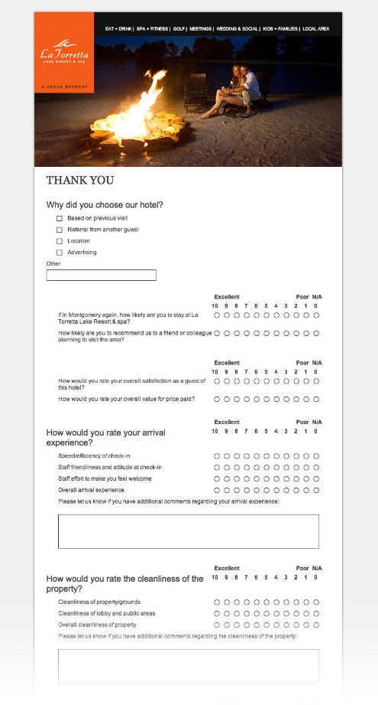

When you ask your customers to give you feedback on your product and/or service, you’re going to learn what they like and don’t like about it. This will enable you to adapt and change your product or service to better meet customer needs and wants.

Mystery shopping- This exercise has three parts.
- Firstly, visit any retail shop and undertake a mystery shop. To do so you will need to identify which shop you will be going to and which product or service you will be assessing.
- Conduct a mystery shop over the telephone of a tourism business.
- You will then need to complete a short PowerPoint presentation which showcases your findings. A PowerPoint template will be provided for you to assist with this. Where possible please provide images of the shop you assessed.

Mystery Shopper Assessment Tool
Name of Business: ____________________________ Type of Business:____________________
Product/s shopped for:___________________________________________________________

Name of Assessor: __________________________________ Date: ________

Assessment Guide
Make your rating of each of the customer service aspects using the following rating scale
1 | 2 | 3 | 4 | 5
Offensive | Poor | Acceptable | Good | Exceptional

First Impressions  - Welcome - greeting and smile | 1 | 2 | 3 | 4 | 5
- Speed of response to your presence | 1 | 2 | 3 | 4 | 5
- First impression of the entrance of the business | 1 | 2 | 3 | 4 | 5
- First impression of inside the business premises | 1 | 2 | 3 | 4 | 5
Communication
- Eye contact and body language | 1 | 2 | 3 | 4 | 5
- Interest in assisting you to find what you want | 1 | 2 | 3 | 4 | 5
- Use of appropriate language - no jargon or slang | 1 | 2 | 3 | 4 | 5
- Overall attitude of salesperson | 1 | 2 | 3 | 4 | 5
Merchandising and Layout
- Products clearly displayed and easy to find | 1 | 2 | 3 | 4 | 5
- Layout inspires browsing | 1 | 2 | 3 | 4 | 5
- A pleasant shopping experience | 1 | 2 | 3 | 4 | 5
- Sale, promotion and impulse lines are well ticketed | 1 | 2 | 3 | 4 | 5
Meeting Customer Needs
- Level of product knowledge | 1 | 2 | 3 | 4 | 5
- Ability to find solutions that met your needs | 1 | 2 | 3 | 4 | 5
- Use of questioning and listening techniques | 1 | 2 | 3 | 4 | 5

Scoring: Please total your ratings: ___________ multiply this number by 1.33 to make a percentage out of 100. ___%

Any specific needs of customers catered for? (e.g Wheelchair access, Special menus)

Other Comments/Recommendations for improvement:

Mystery Shopper Telephone Assessment Tool
Name of Business: ____________________________ Type of Business: ___________________
Product/s asked about: __________________________________________________________

Name of Assessor: __________________________________ Date: ________

Assessment Guide
Make your rating of each of the customer service aspects using the following rating scale
1 | 2 | 3 | 4 | 5
Offensive | Poor | Acceptable | Good | Exceptional

First Impressions  - Welcome greeting | 1 | 2 | 3 | 4 | 5
- Speed of answer | 1 | 2 | 3 | 4 | 5
- First impression of employee | 1 | 2 | 3 | 4 | 5
Communication
- Confidently handled the enquiry | 1 | 2 | 3 | 4 | 5
- Interest in assisting you to find what you want | 1 | 2 | 3 | 4 | 5
- Use of appropriate language - no jargon or slang | 1 | 2 | 3 | 4 | 5
- Overall attitude of salesperson | 1 | 2 | 3 | 4 | 5
Meeting Customer Needs
- Level of product knowledge | 1 | 2 | 3 | 4 | 5
- Ability to find solutions that met your needs | 1 | 2 | 3 | 4 | 5
- Use of questioning and listening techniques | 1 | 2 | 3 | 4 | 5

Scoring: Please total your ratings: ___________ multiply this number by 2 to make a percentage out of 100. ___%

Any specific needs of customers catered for? (e.g Hearing impaired customers)

Other Comments/Recommendations for improvement:

Dealing with customers From other cultures
As we have already discussed cultural differences can be a large barrier to effective customer service. The key to being able to give excellent customer service to people from different cultures is knowledge and understanding. To begin with let’s look at just what culture is.
Culture is the set of assumptions, traditions, and values a community develops over time. Thus, members of a culture other than yours may interpret your behaviour in ways that haven’t occurred to you, because of their community’s own assumptions, traditions, or values.
Your best-intentioned customer facing employees can still create a poor impression with customers from a different part of the world due to cultural differences of which they’re not aware.
So how can you ensure that cultural differences don’t negatively impact on your organisation’s customer service experience? The answer is knowledge. One of the best ways to understand different cultures is through experience. It would be great if you could travel to every country and learn about their culture. However, for most people this isn’t practical. The first place to start though is through looking at the culture in the country you live in.

- What makes up New Zealand culture?

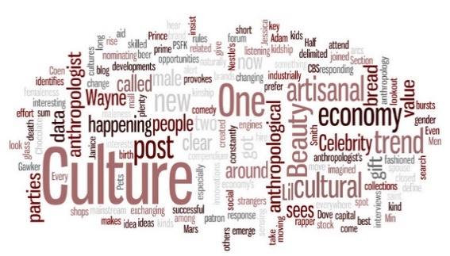
- What do you think foreign visitors say about the New Zealand scenery and environment when they return home?

- What do you think foreign visitors say about New Zealand people when they return home?

- What makes you think your answers to b and c are accurate?

One thing to be aware of is using slang. In New Zealand we have some unique uses for English words. If conversing with a person from another country this may cause some misunderstandings. Can you define these common ‘Kiwi-isms?”
Blokes
Cheers
Choice
Eh / Aye
Gidday/ G’day
Guys
Had it
Heaps
I reckon
Mate
Stuffed
Stoked
Sup?
Sweet as
Ta
Yeah...na
Can you think of any others?

Let’s take a trip
To better understand the visitors that come to New Zealand it would be best to go to those countries that generate the largest numbers of tourists to New Zealand. Below are listed the numbers of international tourists who visited New Zealand between October 2014 and September 2015, and the percentage change from the year before.

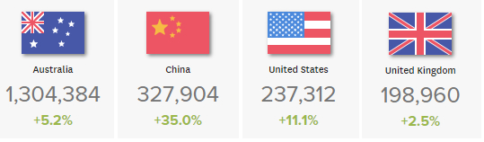
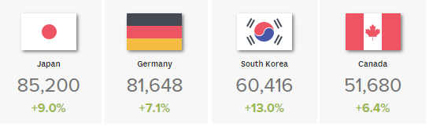

However, it’s not possible for us to travel to all of these countries today, so we are going to go on some video trips to highlight the differences in culture between these countries and New Zealand, Aotearoa.
Let’s begin by looking at our own country New Zealand and its largest city Auckland. You are going to watch a brief travel movie on Auckland prepared by the online travel company Expedia.

Watch the clip and consider the following points as you watch it.
Expedia Auckland
Consider how Auckland is being represented in the video.
- Is this accurate?
- Is it representative of the way you see Auckland?
Think about the:
- People
- Fashion
- Lifestyle
- Housing
- And environment portrayed in the video.

- What does this tell the viewer about New Zealand and its society, culture and environment?
Notes/ Answers:

Expedia Rotorua
- Now do the same for Rotorua. Is this representative of the Rotorua you know?

- Is there a difference between the two clips you have seen?

- What differences in expectations and reality could there be for a person travelling to Auckland and Rotorua?

Other Countries
Now let’s look at some short tourism-based movie clips that focus on our main generating markets for tourism in New Zealand. For each of the clips then:
Think about the:
- People
- Fashion
- Lifestyle
- Housing
- Transportation
- Crowding

Most importantly the differences or similarities between these countries and New Zealand and what does this tell the viewer about each country’s society, culture and environment?

- Australia-
Expedia Sydney
Notes/Assumptions

- China
Kilroy China Travel Tips
Notes/Assumptions

- United States of America
Expedia Seattle
Notes/Assumptions

- United Kingdom
Hostelworld London Travel Guide
Notes/Assumptions

- Japan-
Tokyo Vacation Guide
Notes/Assumptions

- Germany
Lonely Planet Berlin guide
Notes/Assumptions

- South Korea
Expedia Seoul
Notes/Assumptions

- Canada
Expedia Toronto
Notes/Assumptions

From these videos we can see that there are quite a few differences between New Zealand as a destination and the origin countries of visitors who travel here. It is also obvious that there are other differences in the environment, special issues, and the way of life.
As was stated before the best way to learn about other countries is to travel there. The other great way to learn about people from other countries, their culture and way of life is through personal experience. This experience is easy to get once you are working in the travel and tourism industry, where you come into contact with people from other cultures daily.
Read the experience of a tour guide below to see how his job taught him more about people from other cultures.
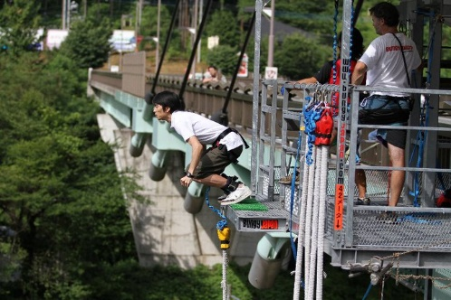
For many years I was a tour guide in both New Zealand and Australia. In this role I was responsible not only for entertaining people with little known facts about flora and fauna, but also booking accommodation and activities, driving the tour bus and being the first point of contact for travellers. In reality you are a friend, a father, a doctor and more to all of those people you show your country to. It can be a demanding job, but most of all it is fun. It is made fun by the people you deal with the tourists, the operators and your work colleagues. You have amazing experiences every day but there is also a great sense of responsibility in caring for large groups of people far away from their homes.
What I found, when it comes to tourists and the differences in culture, is that if we generalise, most people are great to deal with. No matter what culture they come from they simply want to be treated with respect, listened to, and have people care about them as an individual. Problems such as language barriers and lost passports can all be dealt with easily. I bet you that when people look back on their New Zealand holiday they first remember the people, and they remember me. That’s the best you can wish for as a tour guide, to have people fondly remember you for how you did your job and how you made their trip of a lifetime an amazing experience.
After a year or two in the job I could look at most people and tell which country they came from through their physical appearance, or how they dressed. I got to know about the traditions and rituals in their countries. I even got to sample some traditional foods from other countries. When I dealt with tourists I had something to talk about with them. I could say I had met someone from their hometown, or I had tried their food, or I knew a few words in their language. It made interacting much easier. But it wasn’t always the way. When I began I didn’t have that knowledge, but I obtained it through being friendly, caring and helpful, and treating everyone as an individual. I took it upon myself to learn the names of everyone on my tours. It would take me about 2 days to get all 50 people, but I would make sure I did it.
Who doesn’t like to hear the sound of their own name? Well, quite a few people actually. It’s more fitting to say who likes someone not knowing their name?
There are always a lot of generalisations about people from certain countries and it’s true that a little knowledge can help when it comes to different cultures. But you also need to remember that there are many people, just like in New Zealand, who have different likes and behave differently from others. A great example of this would be the Japanese tourists I met. As I dealt with a younger more adventurous market, we often went to major adventure activity operators and gave our passengers the opportunity to partake in these activities.
I remember once getting to the Kawarau Bungy Bridge in Queenstown and having 20 or so people who wanted to jump. Now most people are pretty nervous about a bungy jump, and as a guide you need to spend a lot of time with them encouraging them and listening to what they are saying to help them get the courage for a jump. I had just stopped and had told the passengers to go down to the office and I’d lock the bus and then help them sign in. Well, I did just that, I locked the bus and made my way to the office where my passengers were waiting. I started to encourage some English tourists on my tour and tell them that they would be fine, and it would be a great experience, when one of them looked up and said, “Isn’t that Yoshi from our bus?” Yes, it was, there he was hooked up, rope around his legs, standing on the platform ready to jump. He hardly spoke English, and if you’d believe the stereotype came from a country where everyone was polite, and many weren’t so adventurous. Nobody expected him to be out there so fast. The contrast between him and the English tourists was marked, they were still scared and nervous and he was already out there ready to jump. So be careful with stereotyping people and deciding who they are without first getting to know a little about them.
I guess the best advice I can give you is to remember that it certainly helps to do your research on different cultures and their traditions, but it also helps to treat people as individuals. That through caring and being friendly and understanding many of the barriers we perceive to exist are removed. After that, as you gain more and more experience, your understanding of people from all over the world increases. That to me is what cultural understanding and customer service is all about in the tourism industry.

Tips for communicating with speakers of other languages
- Don’t generalise, treat each person as an individual
- Avoid slang
- Learn the main customs
- Be understanding and empathetic.
- Speak clearly and pronounce your words correctly. Avoid running words together (e.g. Wha do-ya wanna do?).
- Try to simplify your language, but not to a level that is too low. In other words, don’t speak to the other person like they are a child.
- There is a language barrier, this doesn’t mean that the other person is deaf or intellectually challenged. Yelling at the person doesn't make them understand any better than not doing so.
- Do not cover or hide your mouth because listeners will want to watch you as you pronounce your words.
- Be aware that other cultures have different standards regarding touching, eye contact and personal space.
- Be patient and smile. The more relaxed you are, the more you are in control of your communication.
Handling multiple demands and tasks
In an environment where you work with customers there are always going to be multiple demands on your time. You may be faced with serving many customers at one time or having to complete important work tasks whilst serving customers or answering the phone.
Multi-tasking is particularly prevalent in the tourism industry. Take, for example, a tour guide. They must help to arrange passenger activities, organise check-in at hotels and lead groups of up to 50 people all in one day.
The best way to handle multiple customers or clients is by making sure they know that you have to help multiple customers, but still make them aware that you value their service and will do everything you can to assist them with everything they need. This can be achieved by using your communication skills and following established workplace procedures.
If multiple customers require your help at the same time, it’s important you follow a set procedure. Generally speaking, in this situation, you would;
- Greet each customer and acknowledge them. If you were already serving a customer and another customer requires your assistance, then greet them and inform them that you value their business and will be with them as soon as possible.
- Identify what each customer requires. This can assist you in providing excellent and timely customer service and will go a long way to meeting customer needs and wants. For example if you were a travel agent, you may be assisting one customer when another one walks in. All they may require is a brochure. So in that case you would;

- politely excuse yourself from serving your current customer
- greet and acknowledge the new customer, identify their requirements- in this case a brochure
- then be able to successfully deal with their request and then return to your existing customer promptly

Compete the exercise below by writing the missing answers in. Use the skills you have learnt in this unit so far to complete this exercise.
SCENARIO 1: You work in an iSITE visitor center, a tourist from America has come in with some questions for you.
You:

Visitor 1: Good morning, I’d like some information on how I can travel to Wellington from here.
You:

Visitor 1: I’d like to go tomorrow.
You:

Visitor 1: I’ll be staying for 3 days, and then I’m flying out of Wellington to Australia.
You:

Visitor 1: I’d prefer to hire a car actually
You:

Visitor 1: No more than $75 a day including petrol and mileage
You: I can recommend New Zealand Rental cars they have a 4 door Honda Fit for $65 a day including everything.
Visitor 1: That would be great, can you book it for me here?
Visitor 2: Hello, Can you help me?
You: (to visitor 1)

(to Visitor 2)

Visitor 2: Sure, no problem.
You: Sorry, yes, I can book that for you I’ll just need your details and your license and credit card number
Visitor 1: Sure, it’s Wayne Hawke, here’s my license and credit card
You: Great, thank you for that. That’s all booked and confirmed now. Your reference number is ABN 5504888
Visitor 1: That’s wonderful, just one more thing, can you tell me what is the best thing to do in Wellington?
You:

Visitor 1: Okay, I’ll definitely try that. Thanks so much for your help
You:

Visitor 1: No, that’s all. Thanks again, bye
You: (to Visitor 1) Goodbye

(to Visitor 2)

Visitor 2: No problem, I’d like some information on walking tracks in the Nelson area
You:

What to do when you can’t answer a customer enquiry
In any job that you do there will be times when working with customers or colleagues when you are unable to fully assist them. This may be due to the scope of your job, meaning that there are tasks that you aren’t authorised to do, or due to the nature of the request itself and your own abilities to complete the task.
In a situation like this then there are three important steps to follow. These are:
  - Don’t lie to the customer and say you can do something you cannot.
  - Explain to the customer that you cannot assist them with their particular request or issue and refer it to a colleague who can.
  - If a colleague isn’t available to assist the customers at that time, then explain to the customer that whilst you can’t assist them at this time, someone will follow-up with them as soon as possible. Depending on the situation you may collect their phone number and look to have someone call them back later or make an appointment for the customers at a later date, or even explain that they will be helped at a later time in the day or week.

Imagine you are working as a retail travel agent. How would you deal with the following situations?
- It’s lunchtime and you are the only staff member working. Two customers walk into the agency at the same time.

- When serving a customer, the phone rings and you are required to answer it.

- A customer comes in and wants to book a group of 30 people on a trip to Germany. You aren’t authorised to deal with requests for group travel.

Now practice these situations in pairs.

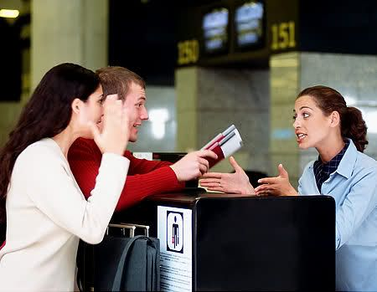
HANDLING CUSTOMER COMPLAINTS
When you are dealing with customers in any industry, the experiences are not always positive. Many times, customers will feel they have a grievance or will want to make a complaint. This may arise from many different situations such as poor customer service, inferior product quality, customer expectations not being met and more.
In the tourism industry clients buy and consume not just products but services too. Customer complaints are not always a negative experience and afford a company the opportunity to improve their products and services, and also the opportunity to ensure the client is satisfied.

What sorts of things do you think clients may complain about if you worked as a:
a) Flight Attendant:

b) River Rafting Guide:

c) Hotel Receptionist:

d) Airline Check in at the airport:

Customer complaints

When dealing with complaints of any nature it is important to follow a complaints handling procedure. Below is a 4-step model for this.

4 Steps to Handling Customer Complaints:

Step One
- Identify the problem

Step Two
- Be empathetic: show understanding and look at it from their point of view
- Ask them what they would like to see happen now

Step Three
- Take action. If you can solve the problem, do so. If you need to refer it to a manager do so.
Step Four
- Follow up. At a later date follow up with the customer to see if they are happy with the solution provided, or a problem still exists. Not only is this good customer service, but it is also good business.

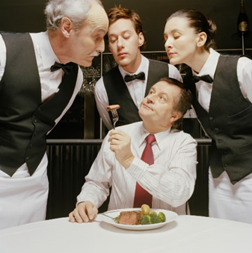
Following the 4-step model, explain how you would deal with a customer complaint in the following situations;

Scenario 1
You work as a waiter in a fine dining restaurant. A customer complains to you that their food is undercooked. You check for yourself and find out that the food is indeed undercooked, and you also find a hair in the food.
Below is shown how would you handle this complaint by following the 4-step method

Step 1:
The problem here is that the customer’s food is undercooked, and there is a hair in the food

Step 2:
Explain that you understand the problem, and in this case identify that it is unacceptable

Step 3:
Take action: Return the food to the kitchen and inform your manager or supervisor. They will be able to deal with refunding the client and continuing the complaint resolution.

Step 4:
Follow up: this would be the manager or supervisor’s job as they would handle any refunds. It is most likely they would formally write to the customer to again express the restaurant’s sorrow that the situation occurred.

Now work as a class or in groups to decide what actions you would take in the following scenario.

Scenario 2
You work for in a duty-free shop at the airport. It’s very busy, and there is a queue of people at your checkout counter. A man jumps the queue and tries to get served before everyone else. He says if he doesn’t get served now, he’ll miss his plane. The other people in the queue aren’t happy with this man. They are looking to you to fix the situation. What will you do?

Step 1:

Step 2:

Step 3:

Step 4:

going the extra mile
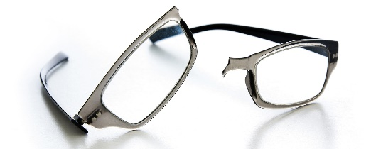
In customer service there are often situations where you can go above and beyond the call of duty. In theory in any customer service role striving to deliver excellence at all times should be the goal. However at times situations present themselves which are unusual or difficult and require you to think outside of the box. The following is an example of excellent customer service being given by a hotel duty manager.

A coach tour of elderly American tourists came into a hotel on the monday of a long weekend public holiday. As it was a public holiday all normal businesses were closed for the day. One of the tourists asked the Duty Manager to assist her. She explained that when the group had visited a local outdoor attraction she had slipped over and had broken her glasses. As she needed these for all day-to-day tasks she was desperate to find a place to fix them.

The Duty Manager explained that due to the public holiday unfortunately all optometrists were closed. The guest was terribly upset and didn’t know what to do. The Duty Manager then asked the woman if he could take a look at her broken glasses. Upon close inspection of the glasses, he found that they were broken in two over the bridge of the nose, and he thought he might be able to repair them himself. He asked the guest if she would mind leaving the glasses with him to see if he could repair them for her. She readily agreed, and the Duty Manager set off to work.

He went to the hotel maintenance room, found some super strength glue, put the glasses into a vice and proceeded to re-join the frame. In 30 minutes, the glasses were back together and, whilst not being 100% as original, were returned to the guest and she was able to wear them and function as normal. This enabled the guest to have the use of her glasses until getting them properly fixed or obtaining a replacement pair. The guest was absolutely delighted.

- How did the Duty Manager “go the extra mile?”

- How do you think his decisions, and ultimate success in fixing the glasses impacted on:
The guest:

The hotel:

Duty Manager:

- Describe a time where you gave excellent customer service that went above and beyond the call of duty. Or describe a time where you received excellent customer service, what happened and what was the outcome?

How one person can impact an entire team

Now watch a short movie on delivering excellent customer service and “going the extra mile”. As you watch jot down some notes on:
- What happened
- How excellent customer service was delivered
- The impacts of the employees’ actions on the customer, the company and other team members

Providing customer service in tourism

See what Rotorua has to offer
In the tourism industry product knowledge and destination knowledge are essential components of being able to meet and exceed customer needs, wants and expectations.
Take the example of a tour guide who may be in Auckland whilst answering traveller questions about what to do in Queenstown, or the bungy jump master who needs to calm a nervous client who is wondering if the cord attached to their legs is safe. They are both engaged in customer service so in situations like the ones described previously would rely on their product and destination knowledge to assist them.
In this module as part of the final assessment you will required to conduct a role play. In this role play your knowledge of the tourism operator used and their products and services will be crucial to your ability to competently complete the final assessment. For the final assessment you will be able to use one of the operators you study in this section here, or another operator of your own choice that you have learnt about in previous TTAI modules you have studied.
For now though you are going to watch a video on tourism operators in Rotorua and then practice a roleplay based on the information gathered from this video.

Now watch the video about Rotorua. Watch the video closely and write down all operators and activities they offer.

You are now going to undertake a role play based on delivering customer service at River Rats.

To be able to satisfactorily complete this roleplay you will need some product knowledge regarding River Rats. You have already briefly looked at their organisation.

- Now let’s look at them in more depth firstly by watching their promotional video.
River Rats

- On the following pages is some general information about River Rats and two of their main products. This was sourced from their website. Read through the information contained in these pages to prepare for the roleplay aspect of this exercise.

Company: | River Rats
What they do? | Adventure tourism rafting company
Main Products and Services: | White water rafting on the, Wairoa and Rangitaiki Rivers and rafting and sledging on the Kaituna River
Location: | Head office, River Rats Base at Hangar 14s, Rotorua Airport, 837 Te Ngae Road, Rotorua. Other bases near Murupara, Tauranga and Turangi
Contact: | Phone: 07-345 6543 or 0800 333 900  Website: www.riverrats.co.nz
Product 1  Kaituna White Water Rafting  General Information | Fast and furious, this exhilarating ride moves you through foamy water and over the awesome seven metre drop.  Although this trip provides full on action the river is pool drop meaning that every rapid is followed by calm water making it very forgiving for a grade 5 river, adventurous beginners are welcome.  Around 15 – 20 minutes of training is provided prior to the trip teaching all the required paddle commands and safety information.  Kaituna Grade 5 (Rivers are graded from 1-6. 1 is very placid with almost no white-water rapids, whilst 6 is the extreme- see River grading information at the end of this form) is a trip that’s not for the fainthearted.  Professional photographs are taken of each River Rats rafting trip and the Kaituna Grade 5 is suitable for all active people aged 13 years and over.  Complimentary pick up is available from central Rotorua accommodation approximately half an hour before the trip. Any pickup will be approximately half an hour before the trip time.
Age/ Fitness limits restrictions/ Recommendations | Suitable for all active people 13 years and over.  Children under 16 must be accompanied by an adult.  Recommended minimum weight limit 40kg, Recommended maximum weight limit 125kg.  Large groups can be taken by arrangement - please contact us for details.
Pricing/Trip Times/Duration | Price: $NZ105.00 per person (valid till 30 September 2015)  Trip Times: 9.30am, 12 pm, 3.30pm  Duration: 45 to 50 minutes on the water, allow around 2 to 2 1/2 hours from the start time at base or around 3 hours including Rotorua trans
Product 2  Sledging | Get your adrenalin fix on Rotorua’s famous Kaituna River, with an ‘at one with the environment’, experience. Sledger’s are in control of your own purpose-built sledge; manoeuvred by flippers on your feet.  Enjoy the scenery, culture and history of this famous river with our friendly, professional guides. Sledging is the most physically difficult of all the trips we offer. Participants must be strong swimmers and physically fit.  Seeing the river at eye level while lying on a board kicking with flippers is not for the faint hearted and is a great personal challenge.  The trip starts with a 10-minute walk carrying your sledge in to below the Kaituna waterfall before taking on the river.  Complimentary pick up is available from central Rotorua accommodation approximately half an hour before the trip.
Age/ Fitness limits restrictions/ Recommendations | As a guide to the level of fitness required, participants should be capable of sprinting 100 metres and recovering reasonably quickly.  Suitable for all active people 13 years and over.  Children under 16 must be accompanied by an adult.  Recommended minimum weight limit 40kg, Recommended maximum weight limit 125kg.  Duration: 45 to 50 minutes on the water, allow around 2 to 2 1/2 hours from the start time at base or around 3 hours including Rotorua transportation.
Pricing/Trip Times/Duration | Sledging available from 01st December - Easter Weekend April, subject to available.  Price: 129 Adult/Child  Trip Times: 9.30am, 12 pm, 3.30pm

Useful Additional Information-River Gradings
- Grade 1
Rapids are small regular waves. The passage is clear and easy to recognise and negotiate. Care may be needed with obstacles like fallen trees and bridge piers.
- Grade 2
Rapids have regular medium sized waves (less than 1 metre), low ledges or drops, easy eddies and gradual bends. The passage is easy to recognise and is generally unobstructed although there may be rocks in the main current, overhanging branches or log jams.
Grade 3
Rapids with fairly high waves (1-2 metres), broken water, stoppers and strong eddies, exposed rocks and small falls. The passage may be difficult to recognise from the river and manoeuvring to negotiate the rapid is required.
- Grade 4
Difficult rapids with high, powerful, irregular waves, broken water, often boiling eddies, strong stoppers, ledges, drops and dangerous exposed rocks. The passage is often difficult to recognise and precise and sequential manoeuvring is required
- Grade 5
Very powerful rapids with very confused and broken water, large drops, violent and fast currents, abrupt turns, difficult powerful stoppers and fast boiling eddies; with numerous obstacles in the main current. Complex, precise and powerful sequential manoeuvring is required. A definite risk to personal safety exists.
- Grade 6
All previous difficulties increased to the limit of practicability. Very confused and violent water so difficult that controlled navigation by raft is virtually impossible. Significantly life threatening if swimming and unrunnable by all but a few experts.

You are now going to undertake a roleplay based on the information provided on the previous pages on River Rats in Rotorua.
Work in threes. One of you will take the role of the customer and the other the customer service representative (CSR) The third student will ‘assess’ the person playing the CSR using the roleplay checklist on the following page. At the end of each role play switch roles ensuring everyone practices being the CSR.
Use the roleplay checklist identified on the next page.
Scenario 1 | CSR | Customer
A walk-in customer has come to the rafting booking office to enquire about the Kaituna white water raft trip. They are looking at completing the trip by themselves only. | It is your job to use your customer service skills (greeting and farewell, questioning, active listening, cultural understanding, positive body language, verbal and non-verbal communication), to meet the needs of the customer. You will also use your extensive product knowledge and knowledge of river grading to assist in the process. | You have travelled to Rotorua for 2 days from your home in Auckland and you are looking for an adventure activity to do. Being an adventurous type of person, nothing scares you and you want to find a rafting trip that will challenge and excite you.  Ask the CSR about:  - The Kaituna River rafting trip  - How challenging it is- river grade?  - The trip highlights  - Duration of the trip  - When can you take the trip- can you go today?  - Price

Scenario 2 | CSR | Customer
A walk-in customer has come to the rafting booking office to enquire about the Kaituna white water raft trip. They are looking at completing the trip by themselves only. | It is your job to use your customer service skills (greeting and farewell, questioning, active listening, cultural understanding, positive body language, verbal and non-verbal communication), to meet the needs of the customer. You will also use your extensive product knowledge and knowledge of river grading to assist in the process. | You are a visitor from London. Having lived in the city all of your life you have heard that there are great adventures on offer in New Zealand. You’ve heard about white water sledging and think this will be a nice way to peacefully cruise down a river on a boat. You also cannot swim, but as you think you’ll be in a boat, this shouldn’t be a problem.  Ask the CSR about:  - The Kaituna River Sledging trip  - How challenging it is- river grade?  - The trip highlights  - Duration of the trip  - When can you take the trip- can you go today?  - Price

ROLEPLAY CHECKLIST (using scenario 1)
OUTCOME 1: Implement basic customer service skills to meet the needs of the customer and enhance the overall visitor experience.

ER | Evidence: (write notes) | C/NYC | C/NYC
1.1  Customer is greeted professionally and within an appropriate timeframe  (should be under 5 seconds). | Write down how the student greeted the customer.
1.2  Appropriate verbal and non-verbal communication is demonstrated. | □ Eye contact  □ Smiling  □ Facing towards them  □ Use of voice pitch/modulation  □ Used appropriate language, i.e. no jargon
1.3  Student demonstrates positive personal behaviour towards the customer. | □ Confidence  □ Enthusiasm  □ Friendliness  □ Interest in the customer
1.4  Product/service knowledge is given which meets the customer’s needs. | How did the student demonstrate product knowledge in accordance with customer needs?
1.5  Literacy and/or numeracy skills are applied to meet the customer needs in accordance with tourism workplace policies and procedures. | If student meets all other roleplay criteria, then mark this as ‘achieved’ as they have demonstrated their literacy and numeracy skills through meeting the customer’s needs in accordance with tourism workplace policies and procedures.
1.6  Additional information and/or advice is offered which suits the customer interaction and enhances the visitor experience. | Identify the additional information and/or advice which the student offered to the customer which enhances the visitor experience.

ROLEPLAY CHECKLIST (using scenario 2)
OUTCOME 1: Implement basic customer service skills to meet the needs of the customer and enhance the overall visitor experience.

ER | Evidence: (write notes) | C/NYC | C/NYC
1.1  Customer is greeted professionally and within an appropriate timeframe  (should be under 5 seconds). | Write down how the student greeted the customer.
1.2  Appropriate verbal and non-verbal communication is demonstrated. | □ Eye contact  □ Smiling  □ Facing towards them  □ Use of voice pitch/modulation  □ Used appropriate language, i.e. no jargon
1.3  Student demonstrates positive personal behaviour towards the customer. | □ Confidence  □ Enthusiasm  □ Friendliness  □ Interest in the customer
1.4  Product/service knowledge is given which meets the customer’s needs. | How did the student demonstrate product knowledge in accordance with customer needs?
1.5  Literacy and/or numeracy skills are applied to meet the customer needs in accordance with tourism workplace policies and procedures. | If student meets all other roleplay criteria, then mark this as ‘achieved’ as they have demonstrated their literacy and numeracy skills through meeting the customer’s needs in accordance with tourism workplace policies and procedures.
1.6  Additional information and/or advice is offered which suits the customer interaction and enhances the visitor experience. | Identify the additional information and/or advice which the student offered to the customer which enhances the visitor experience:

Now complete more in-depth research of Te Puia and Velocity Valley in Rotorua and the products identified in the tables that follow.
Te Puia
Velocity Valley
COMPANY: | TE PUIA
What they do?
Main Products and Services:
Location:
Contact:

Product 1
Te Ra: Day Pass

Age/ Fitness limits restrictions/ Recommendations
Pricing/Trip Times/Duration
Product 2
Te Po: Indigenous evening experience

Age/ Fitness limits restrictions/ Recommendations
Pricing/Trip Times/Duration
Additional Information
COMPANY: | Velocity Valley
What they do?
Main Products and Services:
Location:

Contact:

Product 1
Shweeb

Age/ Fitness limits restrictions/ Recommendations
Pricing/Trip Times/Duration
Product 2
Freefall Xtreme
Age/ Fitness limits restrictions/ Recommendations
Pricing/Trip Times/Duration
Additional Information

Roleplay practice. Work in groups of three, with one student being the ‘assessor’ and the other two roleplaying customer service.
Use the roleplay checklist on the following pages and ensure you competently demonstrate all aspects of the roleplay criteria.

ROLEPLAY CHECKLIST
OUTCOME 1: Implement basic customer service skills to meet the needs of the customer and enhance the overall visitor experience.

ER | Evidence: (write notes) | C/NYC | C/NYC
1.1  Customer is greeted professionally and within an appropriate timeframe  (should be under 5 seconds). | Write down how the student greeted the customer.
1.2  Appropriate verbal and non-verbal communication is demonstrated. | □ Eye contact  □ Smiling  □ Facing towards them  □ Use of voice pitch/modulation  □ Used appropriate language, i.e. no jargon
1.3  Student demonstrates positive personal behaviour towards the customer. | □ Confidence  □ Enthusiasm  □ Friendliness  □ Interest in the customer
1.4  Product/service knowledge is given which meets the customer’s needs. | How did the student demonstrate product knowledge in accordance with customer needs?
.1.5  Literacy and/or numeracy skills are applied to meet the customer needs in accordance with tourism workplace policies and procedures. | If student meets all other roleplay criteria, then mark this as ‘achieved’ as they have demonstrated their literacy and numeracy skills through meeting the customer’s needs in accordance with tourism workplace policies and procedures.
1.6  Additional information and/or advice is offered which suits the customer interaction and enhances the visitor experience | Identify the additional information and/or advice which the student offered to the customer which enhances the visitor experience:

customer service assessment
Choose another tourism operator to base your customer service roleplay assessment on. You may choose an operator you have learnt about earlier in your course. Research your chosen operator thoroughly so you can provide excellent customer service to the customer.

You need to be able to tell a customer about your chosen operator:
- The products and services on offer
- What to expect from the products or services or what the customer will experience
- Additional information which will enhance the customer visitor experience

Complete you own research on what your chosen tourism operation offers to visitors in terms of products and experience. Blank pages follow this page which you can use for your research.

NOTES

NOTES

NOTES

customer with specific needs

In all areas of the travel and tourism industry you are going to find people with specific needs that you need to cater for. It is important that you make all customers feel important and able to enjoy your tour, hotel, airline, etc.
We are now going to identify and describe some specific needs of customers in the travel and tourism industry and identify situations where a customer may need added support.

Make a list of the types of specific needs travellers might have in the tourism industry.

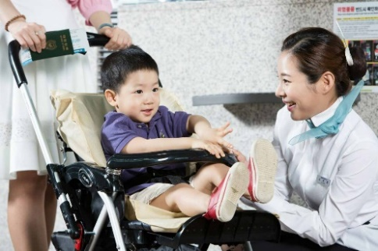
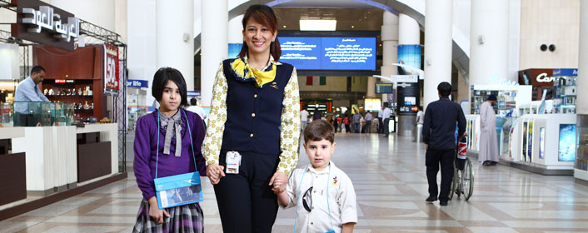

Now we have identified some specific needs travellers, read through each of the following descriptions and identify the which specific need is being discussed

- Although dogs are not allowed in a hotel you would allow this dog as the customer is very dependent on him.
- These children are not travelling with parents on the aeroplane and are under the care of the flight attendant.
- Usually, these passengers are very excited at the thought of travel. However, these passengers don’t handle the prospect of air travel very well and are consumed by anxiety at the very thought of it.

- When communicating with this person you ensure that you are facing them directly so they can fully understand you.
- This person requires a seatbelt extension for the duration of the flight.
- As the motel doesn’t have a Porter service, you personally help this person with their luggage by taking it to their room.

- These passengers are a little frazzled as the people they’re travelling with are disrupting others on the flight.
- During the brief from the Head Flight Attendant, the team is made aware of a particular passenger who may require special attention during today’s flight.

- This person requires a helping hand to embark/disembark the tour bus during today’s excursion.
- Travelling isn’t always fun and in fact it is far from enjoyable for this person. They must travel for an unpleasant reason and they’re struggling to cope.
- This person has certain limitations in skills such as communication and social skills. Travel is possible for this person if they are travelling with a carer.

TOURISM ENVIRONMENT
For each of the following tourism situations think about what support customers with specific needs might require.

ACCOMMODATION:

TRANSPORTATION:

SIGHTSEEING ATTRACTIONS:

Over the next few pages some examples of the impacts on travellers with specific needs are given in terms of transportation, accommodation and attractions. Read through these and answer any questions related to them.
Transportation- MALPENSA EXPRESS
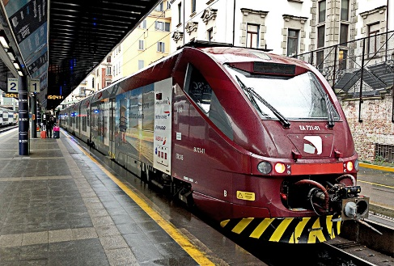
Read through the information below which Malpensa Express gives to disabled people who wish to use their services.

Malpensa Express was launched in 1999 and is the only railway link between the city and the airport. It is located in Milan – Italy. Malpensa Express provides services to disabled people, in line with the characteristics of the railway line and the rolling stock.
The trains featuring this symbol provide services to disabled people
These services must be expressly requested at least five working days before the date of departure for all the trains that do not have a specific caption on the timetable.
For trains featuring this symbol; disabled services can be requested up to one hour before the departure of the train (this service can be provided if the disabled passenger has private assistance to board the train).
If the disabled person travels with a group, the service has to be requested at least five working days before the departure date.
The request has to be sent to:
Customer Care / (Milan Cadorna)
Monday-Friday from 0700 to 2000;
Saturday from 0800 to 2000;
Sundays and holidays from 0830 to 1600.
Email: infocare@lenord.it
The request must include:
the name and the telephone number of the person requesting the service; the date of departure or the travel dates; the origin and destination stations; the departure and arrival schedules;
the accompanying person's name; the characteristics of the wheelchair ( size, non-folding or folding, weight if powered); any particular needs or personal requirements.
The Company will process these requests to see if they are compatible with the characteristics of the trains and of the railway network and then will communicate the timing and the modalities of the service to be provided.

- Do you think these procedures are fair for disabled people? Explain your answer?

- Look at the information in the box below. This is the latest Malpensa Express policy on passengers with physical impairment.

MALPENSA EXPRESS trains provide facilitated access for wheelchairs and have seats reserved for disabled passengers.
To organise assistance, passengers are invited to contact Trenord on +39 0272 494 949 at least 48 hours before departure.
In the absence of such prior communication, by notifying the station or on-board staff in a timely manner, all reasonable efforts will be made to provide the necessary travel assistance to the disabled person or person with reduced mobility, in compliance with EC Regulation no. 1371/2007.
For all information regarding the service: disabili@trenord.it
- How does this differ from their original policy?

Accommodation
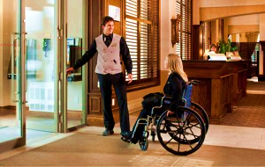
Excerpt from a person with a disability.
“Sometimes it can be so difficult for a disabled traveller to find disabled hotels with all the facilities that fulfill their needs. The word ‘disabled’ does cover a whole multitude of meanings, but in this article I shall talk about those that are wheelchair bound or have mobility impairments. I shall also only talk about hotels in the United Kingdom.”
“Thankfully, with the advent of the internet, it is now easy to check on what facilities a hotel has to offer in assisting the disabled. That is, without having to incur the extra expense of phone calls or grief upon arrival at a hotel only to find that there are no facilities for the disabled”.
“One of the first problems that the disabled traveler has is locating his hotel and finding an appropriate parking space. Usually this is not too bad in a hotel that is in a rural setting where there are often plenty of spaces, but it can be a different matter in a busy city centre hotel.
“Having arrived at the hotel, the next major hurdle is hoping that there are ramps for wheelchair users to get to the hotel entrance and that it isn’t too far. Some hotels do state they are fully accessible for disabled guests. Beware the 200m (70 feet) walk. It is always best to find out how far the walk is to the reception and if there is easy access to rooms.”
“When booking a hotel room it is always advisable to ask if there are disabled rooms near to lifts (elevators), how far they are from reception and what facilities the disabled rooms offer. Shower and bathing facilities should be specially adapted for the disabled, as should the toilets. Things like grab handles and hoists, to many, are an absolute necessity. Often people also require peace and quiet, so it is no good if the room is in the noisiest part of the hotel.”

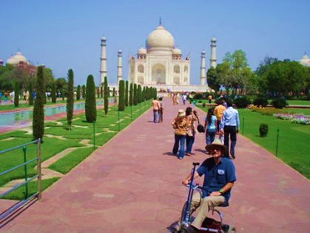
Attractions
India's Taj Mahal, one of the world's most loved monuments, now has nine ramps in the complex. A top tourist destination for both domestic and foreign visitors, this welcome step will help many in wheelchairs enjoy the grand sights.
The luminous, 17th century marble ‘tribute to love’ was built by Mughal emperor Shah Jahan in Agra. It is India’s most popular monument, attracting over 2.5 million visitors annually.
But all these years, disabled visitors - as many as 25 people per day - could only gaze at it from the entrance because nobody had taken their special needs into consideration.
Now, finally, the Archaeological Survey of India (ASI) has responded to the needs of physically challenged tourists by constructing nine ramps at various points in the complex. Besides this, a dozen wheelchairs will also be made available to enable the physically challenged to move easily and conveniently around the grounds of the Taj Mahal.
“Now that people know that the Taj Mahal has become disabled-friendly, more such tourists are likely to visit the monument,” says Munazzar Ali, an ASI official at the Taj.

- How should you treat some with a disability?

People with disabilities are just that: people who have a condition that affects the way they do things. Like snowflakes or fingerprints, no two people with a disability are exactly alike, even if they both have the same type of disability.
People with disabilities ask that you see them as people first and their disability second ... or third...or last. People with disabilities travel for the same reason that people without disabilities travel, they want to see and experience difference cultures, attractions and events.
Because of their disability, people with disabilities may do things differently than able-bodied people:

- They may use a powered wheelchair instead of walking. They may use a white cane or a guide dog to help them avoid obstacles and find their way around.
- They may use a word board or computer to help them communicate verbally, or they may need a sign language interpreter.
- They may need assistance in reading and filling out forms. Or they may need to have materials given to them in different formats, such as Braille.
- Regardless of how an individual with a disability accomplishes specific tasks, people with disabilities have the same rights as any other person to travel.

HOW DO I INTERACT WITH PEOPLE WHO HAVE DISABILITIES?
Excerpt from a person with a disability…
“It is one of my huge rages with the able bodied when they assume that if I'm in my wheelchair, I can't do anything for myself. My first experience with it was at Dunkin Donuts. I got in line, wheeled up. The woman at the counter just started taking orders from people behind me. When I demanded why I wasn't being served, she told me she thought I was just holding a place for my carer.”
“This can also have terrifying side effects, like the time I was at an amusement park and a strange man grabbed my chair and just started wheeling me. He only stopped when I smacked him with my bag and started shouting. Apparently, he "knew" I was lost and was just trying to take me to find the people who brought me - unable to believe I actually drove myself to the park.”
First and foremost, ... do not let fear and uncertainty keep you from getting to know people with disabilities. Fear of the unknown and lack of knowledge about how to act can lead to uneasiness when meeting a person who has a disability. Remember, a person with a disability is a person with feelings. Treat him or her as you would want to be treated.
You cannot always see someone's disability. If a person acts unusually or seems different, just be yourself. Let common sense and friendship break down any barriers you may encounter.
Who am I
BASIC POINTS OF ETIQUETTE
- Avoid asking personal questions about someone's disability. If you must ask, be sensitive and show respect. Do not probe if the person declines to discuss it.
- Be considerate of the extra time it might take for a person with a disability to do or say something.
- Be polite and patient when offering assistance, and wait until your offer is accepted. Listen or ask for specific instructions.
- When planning a meeting or other event, try to anticipate specific arrangements that a person with a disability might need. If a barrier cannot be avoided, make participant aware ahead of time.
- Be respectful of the rights of people with disabilities to use accessible parking spaces.

POSITIVE AND NEGATIVE LANGUAGE
Positive language empowers people. When writing or speaking about people with disabilities, it is important to put the person first. Group designations such as ‘the blind,’ ‘the deaf’ or ‘the disabled’ are inappropriate because they do not reflect the individuality, equality or dignity of people with disabilities. Below are examples of positive and negative phrases. Note that the positive phrases put the person first.
Disability | Affirmative Phrase | Negative Phrase
Cognitive disability | Intellectually challenged | Retarded
Visual disability | Visually impaired | Blind
Physical disability | Disabled | Handicapped, crippled
Hearing disability | Hard of hearing | Deaf

As you have learnt already there are many different types of disabilities. The World Health Organisation states that there are currently 1 billion people in the world who are disabled in some way. This means that it is certain that you will encounter disabled people in all areas of tourism. Using impolite and offensive terms is never acceptable or funny in any situation, but in customer service it is something that would result in the loss of your job.

It’s so easy
You are now going to watch a short movie about how to treat people with disabilities in an airport setting. The movie itself is quite old but is however the message it sends is still relevant. Read through this worksheet now, and then answer the questions in it when the clip is played.
- People with disabilities are sick True/ False
- What are three main areas of disability?

- Intellectual disability is a Learning defect True/False
- The golden rules of treating a person with specific needs are:

- There are 2 types of physical disabilities. What are they and what do they mean?

- Are there communication problems with physically disabled people?

- Paraplegia is damage to the spinal cord below the ………………. level. These people have full use of their arms which are often quite strong.

- Quadriplegia: limited use of body. Possible mobility in hands or arms only. Spinal cord damage has occurred in the ………………. region.

- Which passenger would need more assistance?
Paraplegia / Quadriplegia

- Why is it good to leave passengers with their own mobility aids, such as wheelchair, walking sticks?

- What is Hemiplegia?

- What are the effects of Hemiplegia?

- What is the condition that causes lack of muscle control?

- A Sensory disability involves what kinds of impairment?

- Which impairment from the previous question is more common?

- How can you help someone who is visually impaired?

- When transferring passengers into the sky chair what should you do?
- What is one of the worst myths about people who have disabilities?

Adapting your business to suit specific needs

Read the case study below about adjusting a business for customers with specific needs. Once you have read this your trainer will give you a document with various statements in it related to the benefits of changing a business to suit specific needs customers, and tips on how to do it. You need to cut each statement from the document and identify whether it is a benefit or a tip. At the end of the exercise your trainer will give you a copy of the correct information to stick into your workbook.
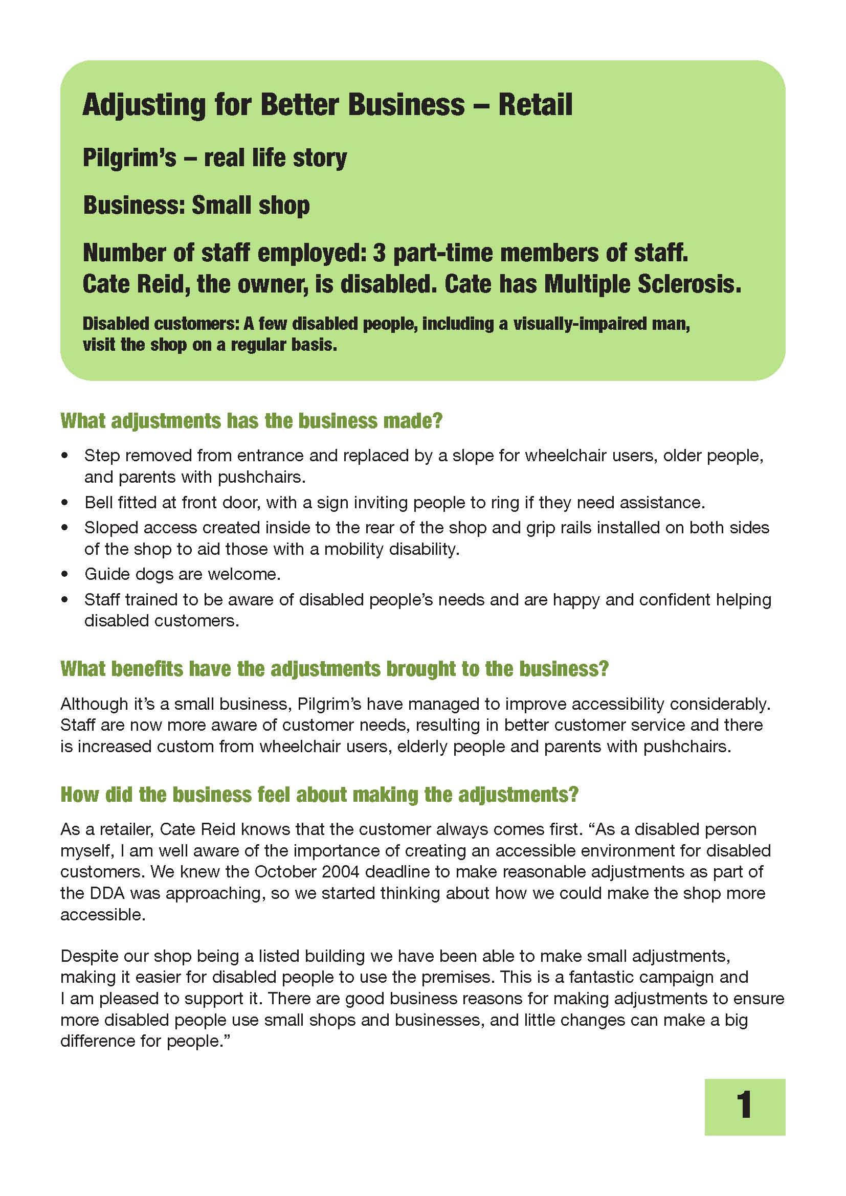
BUSINESS TIPS

BUSINESS BENEFITS

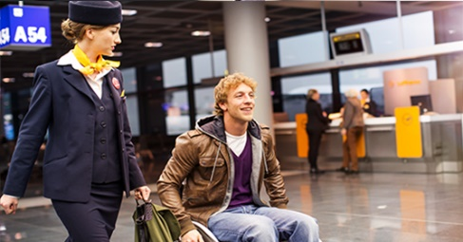
ACCESSIBLE TRAVEL FOR ALL
While accessible travel for those with specific needs should be easy, often something as simple as a night out to eat can be a huge challenge for those in wheelchairs, or who otherwise need assistance, let alone trying to travel through busy airports or train stations.
Obviously, the world is set up to cater to the able bodied individuals. The mandates that require accessibility by all persons are just not specific enough and can leave an individual on a quest for finding an elevator or an access ramp that is conveniently located. Some access ramps are ill constructed to allow for easy access by those in wheelchairs as the quality and design of the ramp makes it very difficult for locomotion under one’s own power.
Often the biggest difficulties facing those who need assistance when travelling is lack of education. Airports and other forms of public transportation need staff who are better informed about providing assistance to those with specific needs.
For instance, airports often tend to wait until passengers are disembarking to call for a wheelchair. The individual must wait while everyone disembarks and often wait even longer for the personnel to arrive with a wheelchair. When there is little time between connecting flights due to late take offs and overcrowded runways, the need for a wheelchair often means missing a flight.
Instead of relegating those most in need of assistance, it seems more beneficial to simply make travel much more realistically accessible. It would be wise to stop hiding elevators in far corners of buildings and create recognition that disabled passengers have regular needs as well.
Accessible travel means ‘any’ cab should be able to pick up person with disabilities rather than there being a particular order required for a specially equipped van to accommodate a wheelchair. Insisting that those with special needs must wait longer for simple amenities, is not only insulting but can also be dangerous.
The constant waiting game that those with disabilities face, is often played alone or in areas where safety is questionable. Airport personnel, train employees or even taxi drivers have seemingly no problem putting disabled passengers aside to wait for the necessary assistance and having little regard for the safety of the individual while they are waiting. As one disables person quotes; “I guess the faster they can tuck us away and keep us out of sight the more comfortable everyone gets to feel”.

Look at the pictures below of various hotel foyers. Assess each picture for how they cater to specific needs.
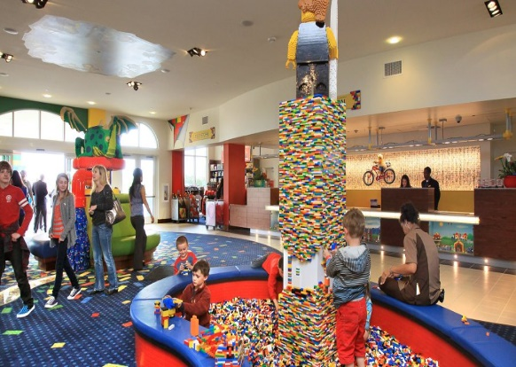
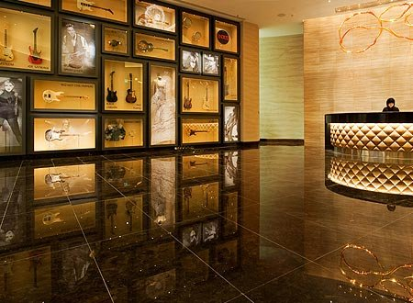
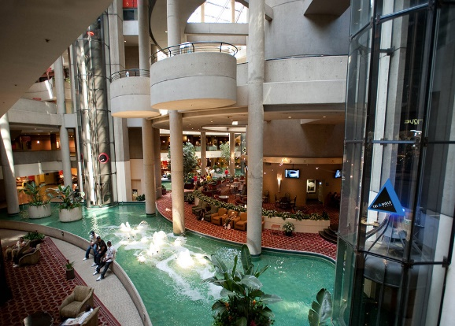


To really understand how a tourism operator caters for people with specific needs it is helpful to actually see the environment in which they operate and to assess it. Before turning our attention to tour operators, and to understand the assessment process better, let’s look at how your New Zealand School of Tourism campus caters for specific needs students and visitors.
Use the form on the next page to help you assess the campus.

Comments:
Campus Name:
Location/ building level(s):

Campus Access:

Facilities for people with specific needs:

Overall evaluation
Discuss the strengths and weakness of this workplace in terms of how they cater for someone who has this specific need.
Explain WHY you think each strength/weakness identified is a good thing or not, and HOW it would impact on a person with that need.

Let’s look now take a more in-depth look at some specific needs and the support you could give to people with these.
VISUAL IMPAIRMENT
Tips on interacting with a person who is blind or has a disability that affects vision:
- When greeting the person, identify yourself and introduce others who may be present.
- Do not leave the person without excusing yourself first.
- When asked to guide someone with a sight disability, never push or pull the person. Allow him or her to take your arm, then walk slightly ahead. Point out doors, stairs or curbs, as you approach them.
- As you enter a room with the person, describe the layout and location of furniture, etc.
- Be specific when describing the location of objects. (Example: "There is a chair three feet from you at eleven o'clock.")
- Do not pet or distract a guide dog. The dog is responsible for its owner's safety and is always working. It is not a pet.
- Every care and attention is to be given to these customers, remember they are an individual first, not a visually impaired person.
On an aircraft
- When you meet them, touch them gently on the arm, introduce yourself, smile and speak directly to their face. If the person is travelling with a seeing person, speak directly to the person who is visually impaired.
- When you come to guide the person to the seat, ask how he or she would like this done. Give clear and precise instructions. If you are going up or down steps, indicate approximately how many there are and when the first or last step is reached. Give directions using ‘right’ or ‘left’ according to the way in which the customer is facing. When helping a blind person to a seat, just place their hand in contact with the seat.
- If the customer has a guide dog but still needs assistance, offer your arm on the opposite side to where the dog is.
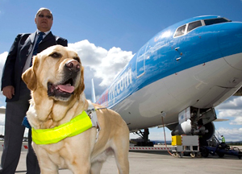
- Once a person who is visually impaired are seated, what would you talk to them about?

- When is a guide dog allowed on a plane in the cabin?

- Will you know in advance to expect a guide dog?

- Do you think if you were a Flight Attendant you should you interact with the dog?

- Where does the dog sit during a flight?

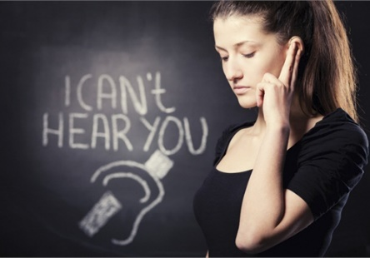
HEARING IMPAIRED
Here are some things to think about when speaking with a person who is hearing impaired or uses a hearing aid:
- Let the person take the lead in establishing the communication mode, such as lip-reading, sign language or writing notes.
- Talk directly to the person, even when a sign language interpreter is present.
- If the person lip-reads, face him or her directly, speak clearly and with a moderate pace.
- With some people, it may help to simplify your sentences and use more facial expressions and body language.

New sign language and the deaf community
People with a hearing impairment are visually orientated people in an aural-oral world. With limited access to spoken language; people with a hearing impairment tend to devise visual ways of communicating through gestures, facial expressions and signs. The development of sign language and the recognition of it as one of New Zealand’s official languages have meant that sign language has now gained status and a recognised importance in New Zealand. Approximately 25,000 people in New Zealand identify as being able to use sign language.
Sign language has its own grammatical structure which is different to English. Sign language depends on how things are visually organised such as:
- Shape of the hand
- The way the hand is arranged
- Visual expression
Communication tips for those using sign language
Here are some simple tips for hearing people when talking to people with hearing impairments who use New Zealand Sign Language (NZSL). Even if you don’t know sign language, these rules will help you mix easily with people who have a hearing impairment. Don't be afraid to use facial expressions, point and gesture; this will make it easy for the person to follow you. Pen and paper is acceptable also.
- Face the person and get their attention before speaking. Remember to maintain eye contact. Don’t turn away when watching them sign to you.
- If you didn't understand what a person signed to you, get them to sign it again if you are confident with sign. It's ok to check, clarify, tell them to slow down.
- Keep lips and face clear of obstruction (e.g. hands, cups, large moustaches).
- People with a hearing impairment ask for attention by waving, stamping, touching or tapping one another, or switching lights on and off.
- In conversation, every contact is very important and people need sufficient personal space for arm movements.
- People with a hearing impairment cannot interrupt conversations the way hearing people can. They need to see what is being said, so they can only pay attention to one person at a time. Deaf people wait for the person who is signing to stop before the next person signs.
- In order to gain turn at signing, amongst a group; people usually have eye contact with all "listener/s", wait for others to stop signing, move hand/s slowly to start signing, or lift a finger or wave hand (in a meeting this means "I want to talk").
- Dim light makes it hard to see facial expressions and NZSL. Make sure the light is in front of you - try not to stand in front of a window.
- Avoid background noise when communicating with someone with a hearing aid.
- Speak clearly and a little more slowly and rephrase rather than repeat
- Use simple gestures, write information down and point to indicate subjects or objects
- At meetings, sit in a semi-circle or circle so that people can see each other.

There are culturally polite ways to interrupt a signed conversation. For example:
- Wait for a small pause before interrupting.
- Wave or tap the shoulder lightly and then wait for the person to look.
- If it is urgent, tap harder.
- Before breaking off a conversation, tell the person you are talking with to 'hold', or point to the interruption so they can see why you will look away.
- Hearing impaired people get annoyed when they are signing and the other person looks away breaking eye contact. That is not a polite way to handle an interruption.
- When two people are signing, it is alright to walk quickly between them, it is not necessary to bend down.
Sign of the times-(this is a shortened -10 minute version- of the previous longer version)

On the next pages you will find a copy of the NZSL alphabet, and some useful words and phrases. Practice these in groups together. Try spelling out your or your classmate’s names and using some polite phrases together.
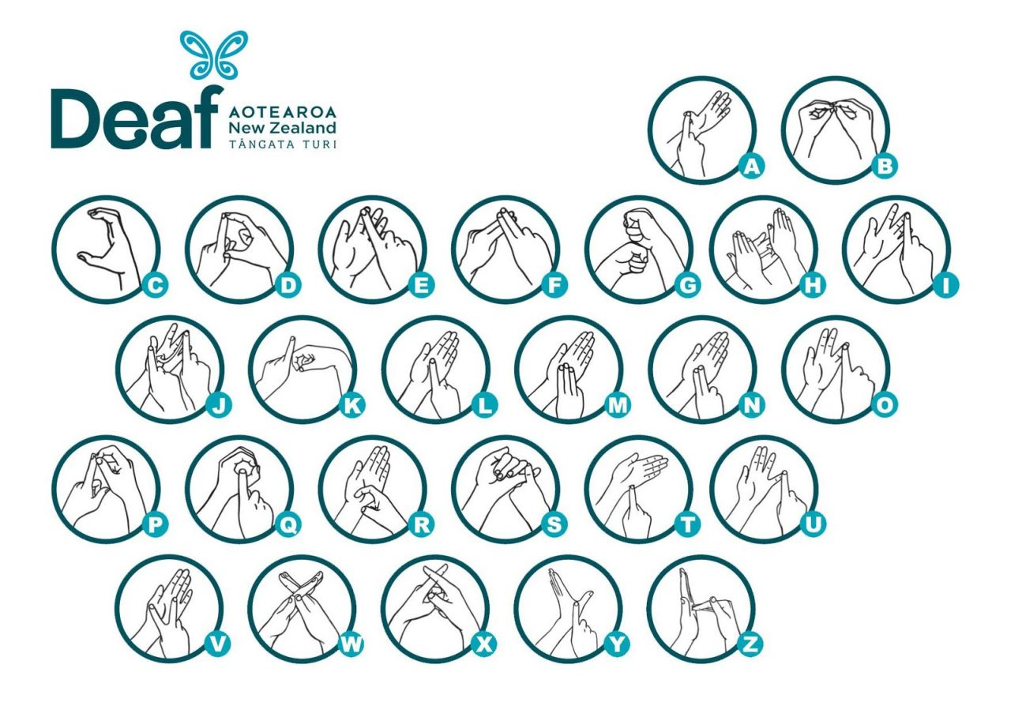
NZSL Alphabet

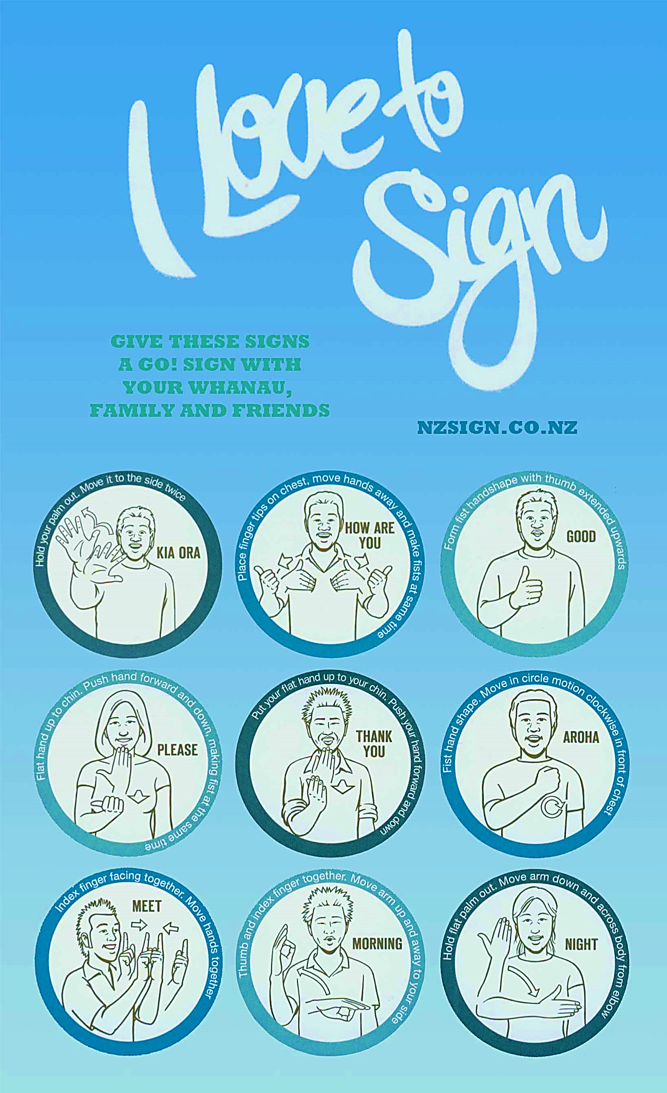
How effective would you be if you were providing customer service in a restaurant to a hearing or visually impaired customer? Work in pairs using the menu below to role play some situations.
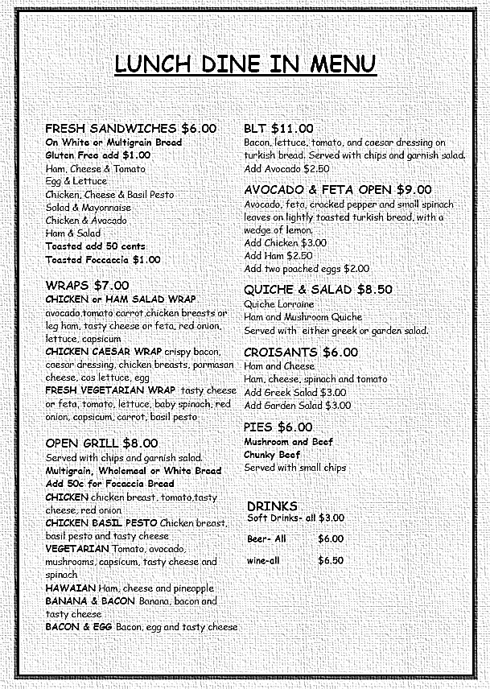

ELDERLY PASSENGERS
An elderly customer may be more fit and active than some of your younger customers. There will, of course, also be more frail customers who could be anxious and worried about travelling. As people get older, they can develop more medical conditions and sometimes be less confident. For example some may be inexperienced flyers and not know how to operate the equipment, such as headsets, reading lights, call bells, air vents, and how to open and lock the toilet doors.
Some coach travellers may have some difficulties entering and exiting the coach. Tours may need to be adapted to suit elderly passengers with more regular breaks, or different types of attractions and activity stops.
There has also been a huge growth in the cruise market in the last two decades and a great proportion of these travellers are elderly.

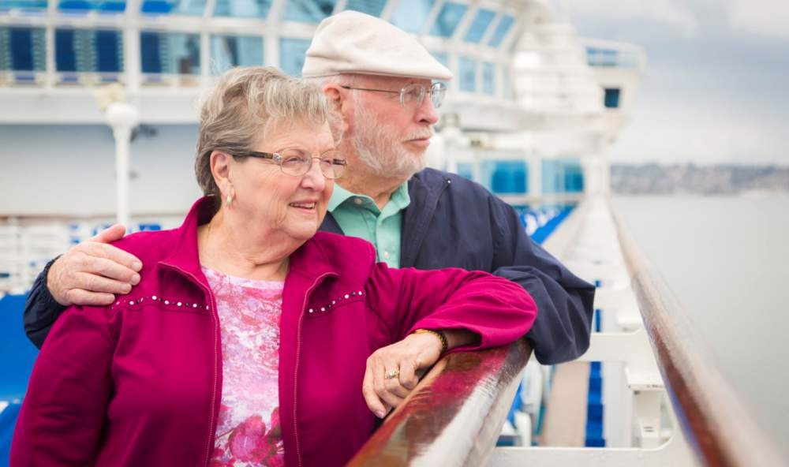
What ways do you think you could be of assistance to an elderly passenger when working in the tourism industry?

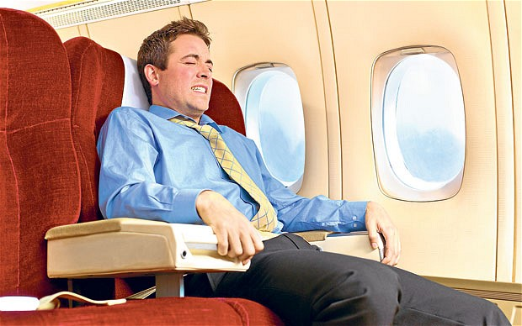
FEAR OF FLYING
Many people have a real genuine fear of being in a confined space, while others fear the aircraft crashing. There are different levels of fear and in most of the severe cases, people don’t fly at all. Those who wish to combat the fear can attend “fear of flying” courses.
Plane Whisperer
Flying with confidence- BA

- What would be some of the signs of a passenger who is afraid of flying?

- What are some things you can do as a member of the tourism industry or flight crew?

other passengers with specific needs
Whilst we have looked at physical and mental issues that may restrict travellers, it is also important to note that there are also many other types of travellers that have specific needs. Some of these may be diet related, with many people being vegetarian, vegan or gluten intolerant. There are also specific needs for people from certain religious groups, pregnant women, people flying with pets and those travelling with small children.

- Why do you think those travelling with small children may need assistance?

- What religious needs might a traveller require?
- How do you think language can create specific needs for travellers?

- How do you think someone’s diet could affect them when travelling? And how do you think tourism businesses cater for this special requirement?

Dietary Requirements
As discussed a person’s dietary requirements can have a great impact on their ability to travel, and their overall health. These requirements are one of the most common specific needs that you will encounter in the tourism and hospitality industries. To get a better understanding of the types of dietary requirements look at the information in the table below from Virgin Atlantic Airlines


Whether your requirements are medical or religious we won't make a meal out of giving you the right food.
You can request a special meal if you book your flight on line or via the Contact Centre no later than 48 hours before your flight departs.
Special meal requests apply to your main meal, and cannot be extended to the snacks and condiments we provide on-board.

Meal | Description | Additional information
Low fat meal | This meal is low in fat and low in dietary cholesterol ingredients with a high fibre content | Available on all flights
Low sodium meal | A low fat, low salt and high fibre meal. The meal shall contain limited or no added salt during the cooking process | Available on all flights
Diabetic meal | This is a low fat, low in salt, low sugar or sugar free meal with high fibre content  Diabetic meals are prepared for those passengers who have type I or type II diabetes or those in the high risk category | Available on all flights
Gluten intolerant meal | Does not contain gluten found in wheat, barley, rye, spelt, unripe spelt grain and oats. This meal is suitable for passengers with coeliac disease or who are wheat intolerant | Available on all flights
Kosher meal | A religious dietary meal that is offered to our Jewish Passengers. All foods are prepared and served according to a strict code of Jewish Kashrut dietary laws.  Please note the Kosher meals supplied on board may contain meat or fish. Meals do not contain foods from non-kashrut sources. Virgin Atlantic is unable to provide different variations of Kosher meals.  On flights from the UK, Kosher Kedassia is supplied  On flights from the USA, Kosher Glatt is supplied  We are currently unable to provide Kosher meals from some destinations (see opposite). As an alternative we can offer a selection of un cut fruit for both meal services.  We apologise for any inconvenience caused to our passengers. | Available on all flights except flights from:  Lagos  Delhi  Mumbai  St Lucia  Montego Bay  Antigua  Barbados  Grenada
Lacto vegetarian meal | Does not contain meat, meat products, fish (including shellfish) or fowl, rennet cheese, animal oils/fats, alcohol, meat gravy but can contain dairy products such as eggs, milk and cheese | Available on all flights
Vegan meal | This meal does not contain any food of animal origin including fish or fowl. No dairy or dairy derivatives are present in this meal for this diet | Available on all flights
Hindu meal | A religious dietary vegetarian meal with a spicy influence. The meal will not contain fish or seafood | Available on all flights
Muslim meal | A religious dietary meal which does not contain pork or alcohol or derivatives of these products. Halal meat will be used for this meal | Available on all flights
Jain meal | A strict Indian vegan meal which does not contain root vegetables | Available on all flights
Asian vegetarian meal | A religious dietary vegetarian meal with a spicy influence. The meal will not contain fish or seafood | Available on all flights
Child meal | This meal is produced for children from the age of 12 months to 12 years old. The meal is easy to eat and recognisable to the child. A child meal is nut friendly meal only. Child meals are prepared in a facility which handles peanuts. Whilst we do not produce child meals containing peanuts, we cannot guarantee a nut free preparation environment therefore the dish may contain nut traces.  Child meals are not vegetarian. If younger passengers require a vegetarian option, a standard vegetarian meal should be ordered.  Child meals are not booked automatically once your flights are confirmed. Passengers must ensure they request child meals as a special dietary requirement.  Child meals can be booked for infants not seated if this is the preferred meal choice for our youngest passengers | Available on all flights
Baby meal | Pureed tinned or bottled foods. No solid foods. Suitable for babies aged up to 12 months. | Available on all flights
Medical Related Meal | We offer a standard selection of medical meals as follows:  - Dairy Free – Non Vegetarian Meal  - Gluten and Dairy Free Meal  - Fruit Platter  - Nut Friendly  - Pureed (liquidised meals)  Unfortunately we cannot offer bespoke meals | Available on all flights

On the next page are two menus. Take a look at each of them and explain what special dietary requirement they are designed for, and how providing menus like this can enhance their business.

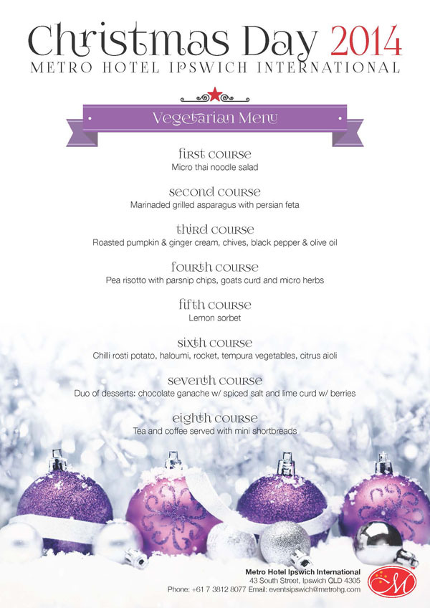
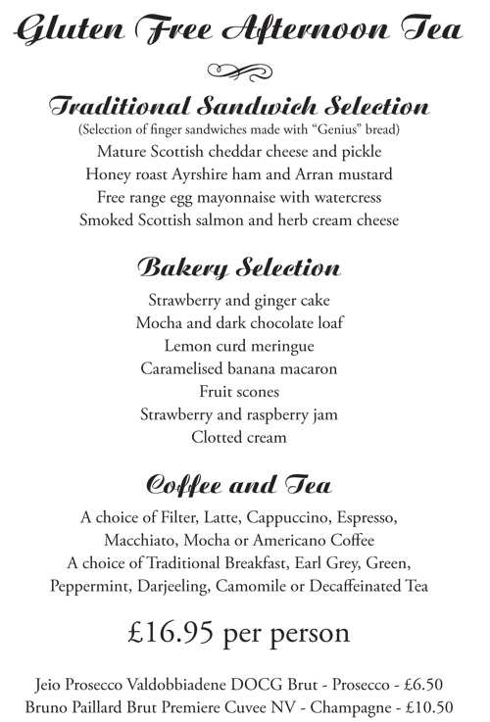
Specific Dietary requirement catered for:

How can this menu enhance the business?
Specific Dietary requirement catered for:

How can this menu enhance the business?
Company regulations
Due to the growing numbers of travellers who have specific needs or requirements, companies have had to develop rules and regulations that deal with this. It is important for both the company and the client to clearly know the rules and their obligations in meeting them. Probably the most heavily regulated part of the tourism industry in terms of specific needs passengers is the airline industry.

- Why do you think airlines have to heavily regulate for specific needs passengers?

- If you were making a booking as a travel agent for a person with specific needs, what information would you need to know before making the booking?

Now read Korean Airline’s regulations on the next few pages and answer the questions that follow;

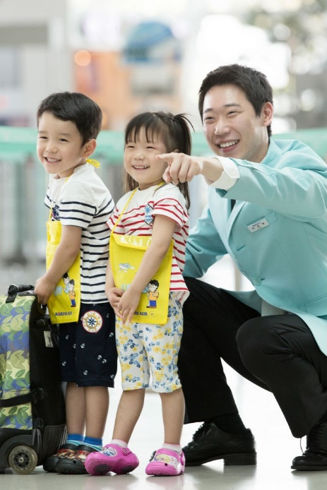

At Korean Air, we want to provide you with peace of mind when it comes to your children travelling alone on both domestic and international flights. Our staff will accompany them from their departure point through to their destination, making sure the journey is safe and comfortable every step of the way.
If you have any questions or want more specific details about our services, please do not hesitate to contact our Service Centre. We understand how stressful this experience can be and want to do all we can to gain your complete trust in Korean Air.

Domestic Flights
- Unaccompanied minors (UM) between the ages of 5 and 12 are eligible for this complimentary service.
- You will need to purchase a standard child fare.
International Flights
- Unaccompanied minors between the ages of 5 and 11 are eligible for this service.
- For any international flight, you will need to purchase a standard adult fare.
- If your children are adolescents between the ages of 12 and 16, they are eligible for Unaccompanied Minor Service on any of our international flights (Discount Fares and Special Fares are excluded). There is, however USD 100 service fee required for each child each way. (CAD 100, if departing from Canada).
- If your children are travelling to or from Canada, the Philippines or Vietnam, please make note of the special requirements below.
To apply, please contact Korean Air at least 24 hours prior to your child’s departure. You will need to provide appropriate identity and contact information of the parent/guardian for both departure and arrival destinations.
What to Expect During the Trip
At check-in, your children will be given an Unaccompanied Minors badge, alerting the airport staff of their special status.
From that point on, your children will be escorted through each phase of the flight by our trained and capable staff who follow set guidelines to ensure their safety and your peace of mind.

At the destination airport, a dedicated Korean Air attendant will wait with your children until the designated, previously identified adult guardian arrives.
NOTE: If the designated adult fails to come, children will be returned to the departure city at the expense of the sending guardian.
TRAVELLERS WITH DISABILITIES
We are committed to providing comfortable, accessible services to all our passengers - including those with disabilities. Please inform your booking agent of any special assistance you may require while travelling with Korean Air. We will be happy to assist you in every way we can to help ensure you have an enjoyable, relaxing experience on board our aircrafts.
Vision or Hearing Impairment
If you would like an escort through the airport, we will be more than happy to oblige. And if you have a personal guide dog, it will be welcomed on board at no extra cost.
Wheelchair Access
Service Guide
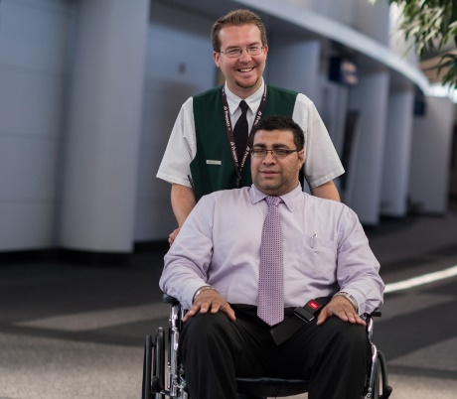
- Korean Air will provide wheelchair to the passenger who has problems with mobility because of disability, illness, old age, etc.
- The assistance will provided from check-in to boarding
- Upon arrival we also help you move to the arrival area. The service does not include moving to outside of the terminal or moving to personal business such as shopping at duty free shops.
- Wheelchair service is provided first to the passengers with prior reservations, if you apply the same day at the airport, the service may be delayed.
- Carrying heavy, large or numerous baggage while using wheelchair is dangerous. Please follow carry-on baggage rule.
Passengers own wheelchair
- You are welcome to bring your own wheelchair, but please note that if the size is over 112(width) X 84(height) cm, it may not be loaded on a small aircraft such as B737, so please check with our service centre before you leave.

- Battery-powered wheelchairs are permitted but require additional safety procedures, so please inform us during booking.

- We normally allow for passenger to check in the wheelchair at the boarding gate and pick it up at arrival, but some airports cannot provide it due to the conditions of the airport facilities.
- You can also request help to move when using your Passenger's own wheelchair
- In-flight wheelchairs, if needed, are available upon request.

On-Board Medical Assistance
At Korean Air, we can offer medical assistance to our passengers only as it applies to the International Air Transport Association's (IATA) Patient Passengers Transport Guidelines. Anyone who will need medical attention, medical oxygen or a stretcher on board is required to obtain a Medical Information Form (MEDIF) dated within 10 days of the flight from a certified medical doctor. In the case of communicable diseases or conditions that could pose a threat to other passengers, a MEDIF will also be necessary prior to travelling with us.
We ask that you confirm the viability of the patient's travel during the booking process. You must register a travel request for an incapacitated passenger at least 72 hours prior to departure for international flights (or 7days in advance if connecting to other airlines) and 48 hours prior for domestic flights.

Stretcher Service
Any passenger who cannot physically utilize normal seating arrangements is eligible for this service. We strongly recommend that a companion accompany the passenger during travel.

Medical Oxygen Service
This service is available to any passenger who requires medical oxygen in the cabin.
- For First- and Business-Class passengers, an additional fee may apply.
- A maximum of 6 bottles of oxygen will be permitted on the aircraft, with a charge of USD 100 per bottle on international flights and KRW 50,000 per bottle on domestic flights.
Breathing Devices On Board
Please notify us at least 48 hours prior to departure if you plan on bringing a device on board.
Device requirements:
- Must be approved by the Federal Aviation Authority or applicable nations and be equipped with a label as proof of certification.
- Only dry-cell battery devices with enough power to last for at least 150% of the maximum flight time will be allowed.
- In-flight power supplies are not available.
- Passengers are solely responsible for operation of their devices.
- You must submit a physician's statement for any POC (Portable
Oxygen Concentrator) device at the time of your reservation.

- What is an unaccompanied minor?

- Why do airlines offer this service?

- How much does it cost to send an unaccompanied minor on a domestic flight with Korean Air, and what is the age of eligibility?

- How much does it cost for the following unaccompanied minors on Korean Air international flights?
- 5-11 year olds
- 12 to 16 year olds

- How much would it cost for a passenger on an international Korean Airways flight to have 4 bottles of medical oxygen?

- What sized wheelchair can travellers bring on all of Korean Air’s services without any difficulties?
- Do wheelchair bound passengers get an extra bag allowance?

- When must you inform the airline about a passenger who is incapacitated, who is flying on a journey that involves a connecting flight with another airline?

- If someone is stretcher bound, what must they do before flying?

Assess a local food court or café/restaurant in your area for how it caters to customers with specific needs. Use the checklist below to complete this task.
WORKPLACE ASSESSMENT
FOOD COURT/ CAFÉ/ RESTAURANT
NAME THE CAFÉ/RESTAURANT YOU HAVE ASSESSED:
__________________________________________________________
Think about and assess this workplace in terms of the following specific needs:
- Physical disability- Wheelchair bound customers
- Dietary requirements
- Physical disability
How have they catered for someone who is wheelchair bound?

Overall evaluation
Discuss the strengths and weakness of this workplace in terms of how they cater for someone who has this specific need.
Explain WHY you think each strength/weakness identified is a good thing or not, and HOW it would impact on a person with that need.

- Dietary requirements
Select one or two restaurants in the food court that have menus which cater for specific dietary needs. Identify what needs are catered for. And list some of the menu items related to this.

Overall evaluation
Discuss the strengths and weakness of this workplace in terms of how they cater for someone who has this specific need.
Explain WHY you think each strength/weakness identified is a good thing or not, and HOW it would impact on a person with that need.

Assess a hotel foyer (or another tourism-related workplace) in your area for how it caters to customers with specific needs. Use the checklist below to complete this task.
WORKPLACE ASSESSMENT

NAME OF THE WORKPLACE YOU HAVE ASSESSED:
__________________________________________________________
Write down three different specific needs of customers – your trainer will provide you with the details. Think about and assess this workplace in terms of these specific needs:

Specific need 1:
Specific need 2:
Specific need 3:

Specific need 1:
- Assessment of workplace
How have they catered for someone who has this specific need?

- Overall evaluation
Discuss the strengths and weakness of this workplace in terms of how they cater for someone who has this specific need.
Explain WHY you think each strength/weakness identified is a good thing or not, and HOW it would impact on a person with that need.

Specific need 2:
- Assessment of workplace
How have they catered for someone who has this specific need?

- Overall evaluation
Discuss the strengths and weakness of this workplace in terms of how they cater for someone who has this specific need.
Explain WHY you think each strength/weakness identified is a good thing or not, and HOW it would impact on a person with that need.

Specific need 3:
- Assessment of workplace
How have they catered for someone who has this specific need?

- Overall evaluation
Discuss the strengths and weakness of this workplace in terms of how they cater for someone who has this specific need.
Explain WHY you think each strength/weakness identified is a good thing or not, and HOW it would impact on a person with that need.

workplace assessment
The final assessment for this module will be during the mini famil component of your course. At this time, you will be required to assess two workplaces using the assessment forms provided.

